**CNN Result Analysis**

**Experiment 1:**

No of epochs: 15

Batch size: 30

Number of layers: 1

Learning rate:0.001

Activation functions: relu

Dropout rates: 0.2

Train on 50000 samples, validate on 10000 samples

Epoch 1/15

50000/50000 [==============================] - 20s 408us/step - loss: 1.4395 - acc: 0.4836 - val_loss: 1.1695 - val_acc: 0.5946

Epoch 2/15

50000/50000 [==============================] - 20s 392us/step - loss: 0.9943 - acc: 0.6575 - val_loss: 0.9148 - val_acc: 0.6831

Epoch 3/15

50000/50000 [==============================] - 19s 389us/step - loss: 0.8450 - acc: 0.7085 - val_loss: 0.8149 - val_acc: 0.7220

Epoch 4/15

50000/50000 [==============================] - 19s 389us/step - loss: 0.7832 - acc: 0.7343 - val_loss: 0.7595 - val_acc: 0.7385

Epoch 5/15

50000/50000 [==============================] - 19s 388us/step - loss: 0.7638 - acc: 0.7472 - val_loss: 0.7621 - val_acc: 0.7622

Epoch 6/15

50000/50000 [==============================] - 19s 389us/step - loss: 0.7883 - acc: 0.7404 - val_loss: 0.7784 - val_acc: 0.7505

Epoch 7/15

50000/50000 [==============================] - 19s 387us/step - loss: 0.7940 - acc: 0.7409 - val_loss: 0.7896 - val_acc: 0.7436

Epoch 8/15

50000/50000 [==============================] - 19s 387us/step - loss: 0.8080 - acc: 0.7386 - val_loss: 0.8491 - val_acc: 0.7302

Epoch 9/15

50000/50000 [==============================] - 19s 386us/step - loss: 0.8271 - acc: 0.7339 - val_loss: 1.0275 - val_acc: 0.7217

Epoch 10/15

50000/50000 [==============================] - 19s 388us/step - loss: 0.8420 - acc: 0.7320 - val_loss: 0.9148 - val_acc: 0.7149

Epoch 11/15

50000/50000 [==============================] - 19s 389us/step - loss: 0.8658 - acc: 0.7237 - val_loss: 0.9369 - val_acc: 0.7184

Epoch 12/15

50000/50000 [==============================] - 19s 387us/step - loss: 0.9064 - acc: 0.7137 - val_loss: 0.8722 - val_acc: 0.7059

Epoch 13/15

50000/50000 [==============================] - 20s 402us/step - loss: 0.9317 - acc: 0.7077 - val_loss: 0.9715 - val_acc: 0.6903

Epoch 14/15

50000/50000 [==============================] - 20s 395us/step - loss: 0.9669 - acc: 0.6971 - val_loss: 1.0824 - val_acc: 0.6649

Epoch 15/15

50000/50000 [==============================] - 19s 387us/step - loss: 0.9854 - acc: 0.6923 - val_loss: 1.2121 - val_acc: 0.6487

10000/10000 [==============================] - 1s 140us/step

Test loss: 1.2121329092025757

Test accuracy: 0.6487

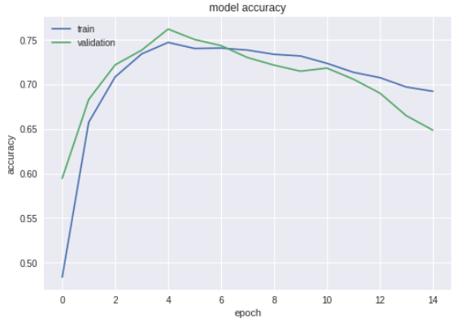

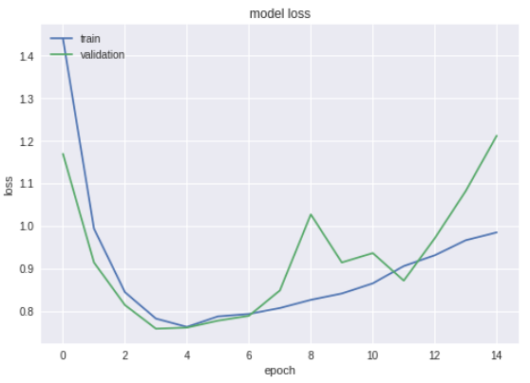

**Comments:** Model seems to overfit a little for this set of configurations. In next experiment I will increase batch size.

**Experiment 2:**

No of epochs: 15

Batch size: 50

Number of layers: 1

Learning rate:0.001

Activation functions: relu

Dropout rates: 0.2

Train on 50000 samples, validate on 10000 samples

Epoch 1/15

50000/50000 [==============================] - 15s 300us/step - loss: 1.5040 - acc: 0.4593 - val_loss: 1.2518 - val_acc: 0.5555

Epoch 2/15

50000/50000 [==============================] - 14s 289us/step - loss: 1.0401 - acc: 0.6366 - val_loss: 0.8892 - val_acc: 0.6908

Epoch 3/15

50000/50000 [==============================] - 14s 288us/step - loss: 0.8528 - acc: 0.7034 - val_loss: 1.0430 - val_acc: 0.6546

Epoch 4/15

50000/50000 [==============================] - 14s 288us/step - loss: 0.7426 - acc: 0.7445 - val_loss: 0.7918 - val_acc: 0.7316

Epoch 5/15

50000/50000 [==============================] - 15s 301us/step - loss: 0.6893 - acc: 0.7660 - val_loss: 0.7294 - val_acc: 0.7552

Epoch 6/15

50000/50000 [==============================] - 15s 294us/step - loss: 0.6645 - acc: 0.7788 - val_loss: 0.7788 - val_acc: 0.7523

Epoch 7/15

50000/50000 [==============================] - 14s 286us/step - loss: 0.6356 - acc: 0.7884 - val_loss: 0.7215 - val_acc: 0.7714

Epoch 8/15

50000/50000 [==============================] - 14s 286us/step - loss: 0.6233 - acc: 0.7943 - val_loss: 0.8415 - val_acc: 0.7279

Epoch 9/15

50000/50000 [==============================] - 14s 287us/step - loss: 0.6141 - acc: 0.7981 - val_loss: 0.8086 - val_acc: 0.7424

Epoch 10/15

50000/50000 [==============================] - 14s 286us/step - loss: 0.6145 - acc: 0.8001 - val_loss: 0.9054 - val_acc: 0.7510

Epoch 11/15

50000/50000 [==============================] - 14s 286us/step - loss: 0.6058 - acc: 0.8041 - val_loss: 0.7259 - val_acc: 0.7580

Epoch 12/15

50000/50000 [==============================] - 14s 287us/step - loss: 0.6054 - acc: 0.8031 - val_loss: 0.7420 - val_acc: 0.7558

Epoch 13/15

50000/50000 [==============================] - 14s 286us/step - loss: 0.6067 - acc: 0.8052 - val_loss: 0.7697 - val_acc: 0.7537

Epoch 14/15

50000/50000 [==============================] - 14s 287us/step - loss: 0.6121 - acc: 0.8020 - val_loss: 0.8533 - val_acc: 0.7403

Epoch 15/15

50000/50000 [==============================] - 14s 286us/step - loss: 0.6171 - acc: 0.8022 - val_loss: 0.9487 - val_acc: 0.7509

10000/10000 [==============================] - 1s 138us/step

Test loss: 0.9486719012260437

Test accuracy: 0.7509

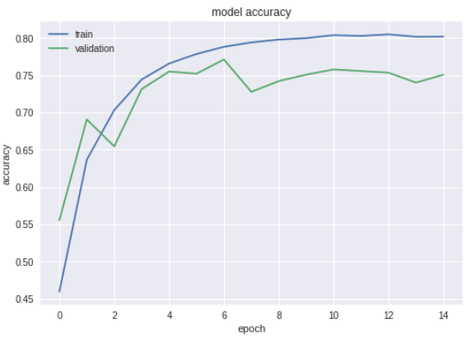

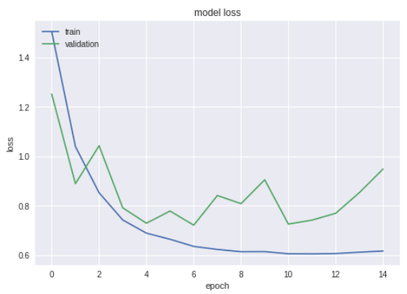

**Comments:** This model is clearly overfitting. Hence in next experiment I will reduce the batch size but will increase the number of epochs.

**Experiment 3:**

No of epochs: 25

Batch size: 30

Number of layers: 1

Learning rate:0.001

Activation functions: relu

Dropout rates: 0.2

Train on 50000 samples, validate on 10000 samples

Epoch 1/25

50000/50000 [==============================] - 21s 427us/step - loss: 1.4178 - acc: 0.4914 - val_loss: 1.0328 - val_acc: 0.6346

Epoch 2/25

50000/50000 [==============================] - 20s 407us/step - loss: 0.9783 - acc: 0.6621 - val_loss: 1.1195 - val_acc: 0.6182

Epoch 3/25

50000/50000 [==============================] - 20s 404us/step - loss: 0.8450 - acc: 0.7087 - val_loss: 1.1302 - val_acc: 0.6329

Epoch 4/25

50000/50000 [==============================] - 20s 405us/step - loss: 0.7917 - acc: 0.7315 - val_loss: 0.7650 - val_acc: 0.7450

Epoch 5/25

50000/50000 [==============================] - 20s 402us/step - loss: 0.7799 - acc: 0.7426 - val_loss: 0.7916 - val_acc: 0.7363

Epoch 6/25

50000/50000 [==============================] - 20s 400us/step - loss: 0.7947 - acc: 0.7403 - val_loss: 0.8911 - val_acc: 0.7297

Epoch 7/25

50000/50000 [==============================] - 20s 401us/step - loss: 0.7972 - acc: 0.7414 - val_loss: 0.9066 - val_acc: 0.7214

Epoch 8/25

50000/50000 [==============================] - 20s 403us/step - loss: 0.8150 - acc: 0.7384 - val_loss: 1.3535 - val_acc: 0.6746

Epoch 9/25

50000/50000 [==============================] - 21s 425us/step - loss: 0.8279 - acc: 0.7338 - val_loss: 0.9085 - val_acc: 0.7190

Epoch 10/25

50000/50000 [==============================] - 20s 403us/step - loss: 0.8435 - acc: 0.7270 - val_loss: 0.7752 - val_acc: 0.7497

Epoch 11/25

50000/50000 [==============================] - 20s 399us/step - loss: 0.8604 - acc: 0.7247 - val_loss: 0.9673 - val_acc: 0.6976

Epoch 12/25

50000/50000 [==============================] - 20s 397us/step - loss: 0.8780 - acc: 0.7213 - val_loss: 0.9035 - val_acc: 0.7103

Epoch 13/25

50000/50000 [==============================] - 20s 396us/step - loss: 0.9104 - acc: 0.7124 - val_loss: 0.9551 - val_acc: 0.6828

Epoch 14/25

50000/50000 [==============================] - 20s 396us/step - loss: 0.9332 - acc: 0.7064 - val_loss: 0.9861 - val_acc: 0.7134

Epoch 15/25

50000/50000 [==============================] - 20s 400us/step - loss: 0.9477 - acc: 0.7033 - val_loss: 1.0678 - val_acc: 0.6599

Epoch 16/25

50000/50000 [==============================] - 20s 398us/step - loss: 0.9572 - acc: 0.7026 - val_loss: 0.9060 - val_acc: 0.7263

Epoch 17/25

50000/50000 [==============================] - 20s 398us/step - loss: 0.9883 - acc: 0.6895 - val_loss: 1.0309 - val_acc: 0.6604

Epoch 18/25

50000/50000 [==============================] - 20s 400us/step - loss: 0.9989 - acc: 0.6883 - val_loss: 0.9786 - val_acc: 0.7177

Epoch 19/25

50000/50000 [==============================] - 20s 397us/step - loss: 1.0137 - acc: 0.6843 - val_loss: 0.9386 - val_acc: 0.7174

Epoch 20/25

50000/50000 [==============================] - 20s 396us/step - loss: 1.0318 - acc: 0.6790 - val_loss: 1.2070 - val_acc: 0.6620

Epoch 21/25

50000/50000 [==============================] - 20s 396us/step - loss: 1.0559 - acc: 0.6728 - val_loss: 1.0307 - val_acc: 0.6857

Epoch 22/25

50000/50000 [==============================] - 20s 396us/step - loss: 1.0762 - acc: 0.6658 - val_loss: 1.0037 - val_acc: 0.6861

Epoch 23/25

50000/50000 [==============================] - 20s 396us/step - loss: 1.1169 - acc: 0.6558 - val_loss: 1.0286 - val_acc: 0.6626

Epoch 24/25

50000/50000 [==============================] - 21s 422us/step - loss: 1.1081 - acc: 0.6542 - val_loss: 1.0360 - val_acc: 0.6533

Epoch 25/25

50000/50000 [==============================] - 20s 398us/step - loss: 1.1282 - acc: 0.6492 - val_loss: 0.9778 - val_acc: 0.6939

10000/10000 [==============================] - 1s 146us/step

Test loss: 0.977810641670227

Test accuracy: 0.6939

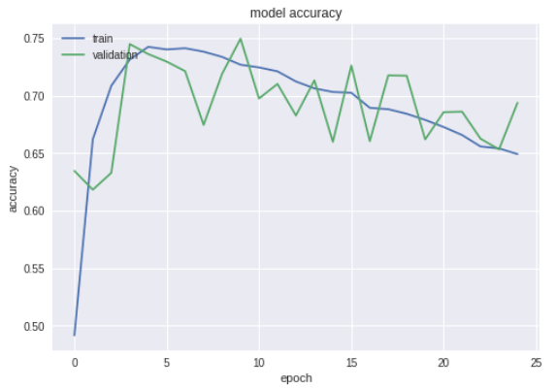

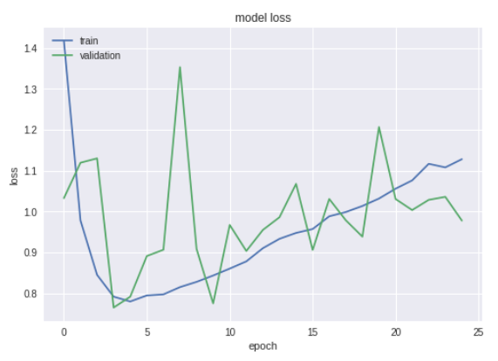

**Comments:** This model is underfitting. So, I will include one more hidden layer and will see the results.

**Experiment 4:**

No of epochs: 15

Batch size: 30

Number of layers: 2

Learning rate:0.001

Activation functions: relu

Dropout rates: 0.2

Train on 50000 samples, validate on 10000 samples

Epoch 1/15

50000/50000 [==============================] - 24s 470us/step - loss: 1.6425 - acc: 0.3982 - val_loss: 1.2994 - val_acc: 0.5316

Epoch 2/15

50000/50000 [==============================] - 23s 452us/step - loss: 1.1978 - acc: 0.5755 - val_loss: 1.2903 - val_acc: 0.5656

Epoch 3/15

50000/50000 [==============================] - 23s 463us/step - loss: 1.0333 - acc: 0.6416 - val_loss: 0.9238 - val_acc: 0.6807

Epoch 4/15

50000/50000 [==============================] - 23s 451us/step - loss: 0.9507 - acc: 0.6757 - val_loss: 0.8718 - val_acc: 0.7079

Epoch 5/15

50000/50000 [==============================] - 22s 440us/step - loss: 0.9315 - acc: 0.6876 - val_loss: 0.8512 - val_acc: 0.7267

Epoch 6/15

50000/50000 [==============================] - 22s 432us/step - loss: 0.9382 - acc: 0.6911 - val_loss: 1.0547 - val_acc: 0.6531

Epoch 7/15

50000/50000 [==============================] - 22s 433us/step - loss: 0.9567 - acc: 0.6886 - val_loss: 0.9197 - val_acc: 0.6932

Epoch 8/15

50000/50000 [==============================] - 22s 433us/step - loss: 0.9713 - acc: 0.6843 - val_loss: 1.0816 - val_acc: 0.6315

Epoch 9/15

50000/50000 [==============================] - 21s 426us/step - loss: 1.0117 - acc: 0.6761 - val_loss: 1.0791 - val_acc: 0.6342

Epoch 10/15

50000/50000 [==============================] - 21s 424us/step - loss: 1.0281 - acc: 0.6655 - val_loss: 1.0420 - val_acc: 0.6538

Epoch 11/15

50000/50000 [==============================] - 21s 424us/step - loss: 1.0468 - acc: 0.6643 - val_loss: 0.9720 - val_acc: 0.6659

Epoch 12/15

50000/50000 [==============================] - 21s 426us/step - loss: 1.0906 - acc: 0.6548 - val_loss: 1.0100 - val_acc: 0.6641

Epoch 13/15

50000/50000 [==============================] - 21s 426us/step - loss: 1.1266 - acc: 0.6433 - val_loss: 1.0737 - val_acc: 0.6641

Epoch 14/15

50000/50000 [==============================] - 21s 422us/step - loss: 1.1910 - acc: 0.6322 - val_loss: 0.9357 - val_acc: 0.7008

Epoch 15/15

50000/50000 [==============================] - 21s 426us/step - loss: 1.2452 - acc: 0.6186 - val_loss: 1.3593 - val_acc: 0.5255

10000/10000 [==============================] - 2s 155us/step

Test loss: 1.3592705606460571

Test accuracy: 0.5255

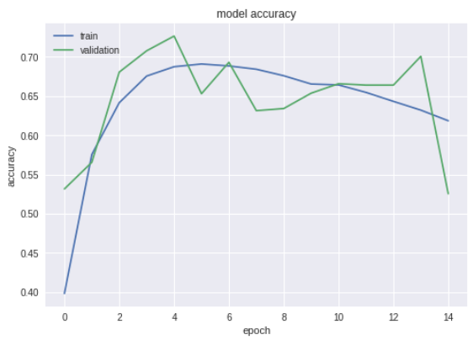

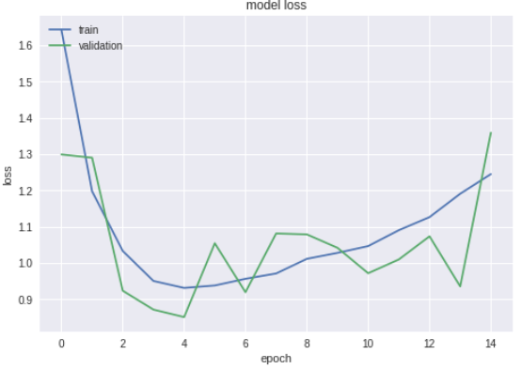

**Comments:** Now we will try to increase batch size and see the results.

**Experiment 5:**

No of epochs: 15

Batch size: 50

Number of layers: 2

Learning rate:0.001

Activation functions: relu

Dropout rates: 0.2

Train on 50000 samples, validate on 10000 samples

Epoch 1/15

50000/50000 [==============================] - 16s 324us/step - loss: 1.7433 - acc: 0.3638 - val_loss: 1.3238 - val_acc: 0.5243

Epoch 2/15

50000/50000 [==============================] - 16s 311us/step - loss: 1.2801 - acc: 0.5426 - val_loss: 1.2051 - val_acc: 0.5670

Epoch 3/15

50000/50000 [==============================] - 15s 302us/step - loss: 1.0670 - acc: 0.6225 - val_loss: 0.9598 - val_acc: 0.6699

Epoch 4/15

50000/50000 [==============================] - 15s 304us/step - loss: 0.9375 - acc: 0.6721 - val_loss: 0.9024 - val_acc: 0.6917

Epoch 5/15

50000/50000 [==============================] - 15s 304us/step - loss: 0.8573 - acc: 0.7038 - val_loss: 0.7824 - val_acc: 0.7355

Epoch 6/15

50000/50000 [==============================] - 16s 313us/step - loss: 0.7942 - acc: 0.7271 - val_loss: 0.7658 - val_acc: 0.7447

Epoch 7/15

50000/50000 [==============================] - 15s 308us/step - loss: 0.7674 - acc: 0.7384 - val_loss: 0.7795 - val_acc: 0.7484

Epoch 8/15

50000/50000 [==============================] - 15s 303us/step - loss: 0.7423 - acc: 0.7482 - val_loss: 0.7334 - val_acc: 0.7562

Epoch 9/15

50000/50000 [==============================] - 15s 303us/step - loss: 0.7329 - acc: 0.7555 - val_loss: 0.7394 - val_acc: 0.7527

Epoch 10/15

50000/50000 [==============================] - 15s 302us/step - loss: 0.7365 - acc: 0.7534 - val_loss: 0.7720 - val_acc: 0.7483

Epoch 11/15

50000/50000 [==============================] - 15s 302us/step - loss: 0.7340 - acc: 0.7568 - val_loss: 0.8553 - val_acc: 0.7153

Epoch 12/15

50000/50000 [==============================] - 15s 303us/step - loss: 0.7384 - acc: 0.7555 - val_loss: 0.8546 - val_acc: 0.7210

Epoch 13/15

50000/50000 [==============================] - 15s 300us/step - loss: 0.7477 - acc: 0.7520 - val_loss: 0.7793 - val_acc: 0.7403

Epoch 14/15

50000/50000 [==============================] - 15s 301us/step - loss: 0.7565 - acc: 0.7515 - val_loss: 0.7301 - val_acc: 0.7574

Epoch 15/15

50000/50000 [==============================] - 15s 301us/step - loss: 0.7699 - acc: 0.7506 - val_loss: 0.8064 - val_acc: 0.7326

10000/10000 [==============================] - 2s 151us/step

Test loss: 0.806414825630188

Test accuracy: 0.7326

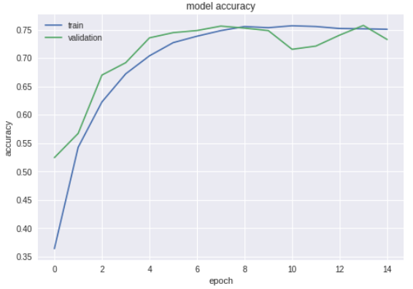

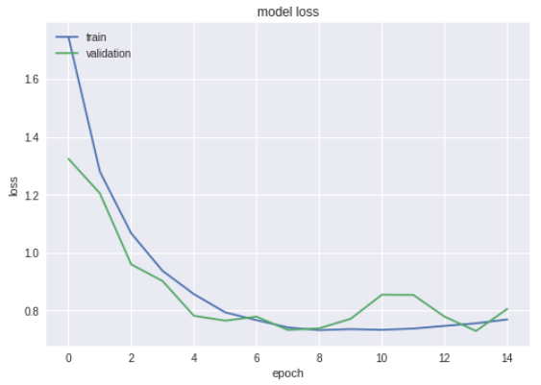

**Comments:** This model seems good so far. Again, increasing the batch size.

**Experiment 6:**

No of epochs: 15

Batch size: 100

Number of layers: 2

Learning rate:0.001

Activation functions: relu

Dropout rates: 0.2

Train on 50000 samples, validate on 10000 samples

Epoch 1/15

50000/50000 [==============================] - 13s 254us/step - loss: 1.8688 - acc: 0.3101 - val_loss: 1.5209 - val_acc: 0.4440

Epoch 2/15

50000/50000 [==============================] - 12s 233us/step - loss: 1.4203 - acc: 0.4903 - val_loss: 1.2485 - val_acc: 0.5542

Epoch 3/15

50000/50000 [==============================] - 12s 233us/step - loss: 1.2064 - acc: 0.5713 - val_loss: 1.0704 - val_acc: 0.6164

Epoch 4/15

50000/50000 [==============================] - 12s 232us/step - loss: 1.0528 - acc: 0.6261 - val_loss: 0.9559 - val_acc: 0.6635

Epoch 5/15

50000/50000 [==============================] - 12s 233us/step - loss: 0.9427 - acc: 0.6681 - val_loss: 0.9031 - val_acc: 0.6889

Epoch 6/15

50000/50000 [==============================] - 12s 233us/step - loss: 0.8433 - acc: 0.7035 - val_loss: 0.8235 - val_acc: 0.7168

Epoch 7/15

50000/50000 [==============================] - 12s 232us/step - loss: 0.7739 - acc: 0.7318 - val_loss: 0.7352 - val_acc: 0.7414

Epoch 8/15

50000/50000 [==============================] - 12s 232us/step - loss: 0.7215 - acc: 0.7461 - val_loss: 0.8640 - val_acc: 0.7136

Epoch 9/15

50000/50000 [==============================] - 12s 232us/step - loss: 0.6784 - acc: 0.7637 - val_loss: 0.6926 - val_acc: 0.7627

Epoch 10/15

50000/50000 [==============================] - 12s 232us/step - loss: 0.6417 - acc: 0.7764 - val_loss: 0.6922 - val_acc: 0.7644

Epoch 11/15

50000/50000 [==============================] - 12s 231us/step - loss: 0.6091 - acc: 0.7881 - val_loss: 0.8798 - val_acc: 0.7254

Epoch 12/15

50000/50000 [==============================] - 11s 230us/step - loss: 0.5839 - acc: 0.7960 - val_loss: 0.6565 - val_acc: 0.7800

Epoch 13/15

50000/50000 [==============================] - 12s 231us/step - loss: 0.5608 - acc: 0.8061 - val_loss: 0.7251 - val_acc: 0.7665

Epoch 14/15

50000/50000 [==============================] - 11s 230us/step - loss: 0.5453 - acc: 0.8109 - val_loss: 0.6868 - val_acc: 0.7772

Epoch 15/15

50000/50000 [==============================] - 11s 230us/step - loss: 0.5321 - acc: 0.8167 - val_loss: 0.6463 - val_acc: 0.7904

10000/10000 [==============================] - 2s 150us/step

Test loss: 0.6463181330680847

Test accuracy: 0.7904

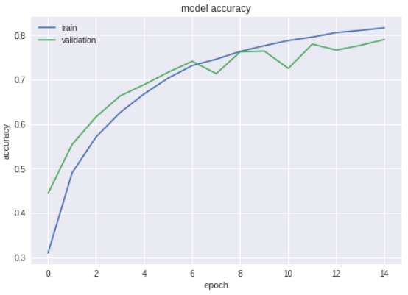

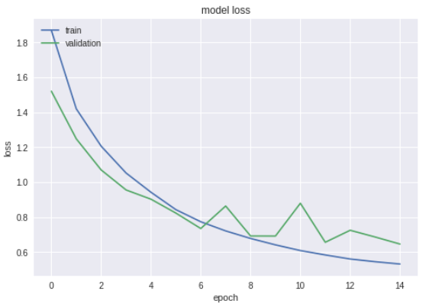

**Comments:** Got testing accuracy of 0.7904 while training accuracy is 0.8167. Now in next experiment I will increase epochs.

**Experiment 7:**

No of epochs: 25

Batch size: 100

Number of layers: 2

Learning rate:0.001

Activation functions: relu

Dropout rates: 0.2

Train on 50000 samples, validate on 10000 samples

Epoch 1/25

50000/50000 [==============================] - 13s 255us/step - loss: 1.8344 - acc: 0.3271 - val_loss: 1.5868 - val_acc: 0.4264

Epoch 2/25

50000/50000 [==============================] - 12s 240us/step - loss: 1.4028 - acc: 0.4953 - val_loss: 1.2746 - val_acc: 0.5498

Epoch 3/25

50000/50000 [==============================] - 12s 235us/step - loss: 1.1817 - acc: 0.5809 - val_loss: 1.0625 - val_acc: 0.6264

Epoch 4/25

50000/50000 [==============================] - 12s 236us/step - loss: 1.0406 - acc: 0.6332 - val_loss: 0.9237 - val_acc: 0.6759

Epoch 5/25

50000/50000 [==============================] - 12s 233us/step - loss: 0.9276 - acc: 0.6752 - val_loss: 0.8494 - val_acc: 0.7020

Epoch 6/25

50000/50000 [==============================] - 12s 233us/step - loss: 0.8389 - acc: 0.7080 - val_loss: 0.7907 - val_acc: 0.7323

Epoch 7/25

50000/50000 [==============================] - 12s 233us/step - loss: 0.7710 - acc: 0.7333 - val_loss: 0.7763 - val_acc: 0.7327

Epoch 8/25

50000/50000 [==============================] - 12s 236us/step - loss: 0.7184 - acc: 0.7504 - val_loss: 0.7589 - val_acc: 0.7390

Epoch 9/25

50000/50000 [==============================] - 12s 241us/step - loss: 0.6779 - acc: 0.7657 - val_loss: 0.7149 - val_acc: 0.7552

Epoch 10/25

50000/50000 [==============================] - 12s 233us/step - loss: 0.6376 - acc: 0.7792 - val_loss: 0.6472 - val_acc: 0.7860

Epoch 11/25

50000/50000 [==============================] - 12s 234us/step - loss: 0.6092 - acc: 0.7887 - val_loss: 0.6810 - val_acc: 0.7761

Epoch 12/25

50000/50000 [==============================] - 12s 234us/step - loss: 0.5866 - acc: 0.7972 - val_loss: 0.6597 - val_acc: 0.7777

Epoch 13/25

50000/50000 [==============================] - 12s 235us/step - loss: 0.5605 - acc: 0.8061 - val_loss: 0.6513 - val_acc: 0.7824

Epoch 14/25

50000/50000 [==============================] - 12s 234us/step - loss: 0.5303 - acc: 0.8167 - val_loss: 0.6945 - val_acc: 0.7810

Epoch 15/25

50000/50000 [==============================] - 12s 234us/step - loss: 0.5188 - acc: 0.8209 - val_loss: 0.7407 - val_acc: 0.7649

Epoch 16/25

50000/50000 [==============================] - 12s 233us/step - loss: 0.5085 - acc: 0.8259 - val_loss: 0.6524 - val_acc: 0.7883

Epoch 17/25

50000/50000 [==============================] - 12s 233us/step - loss: 0.4915 - acc: 0.8306 - val_loss: 0.6315 - val_acc: 0.7958

Epoch 18/25

50000/50000 [==============================] - 12s 233us/step - loss: 0.4864 - acc: 0.8316 - val_loss: 0.7232 - val_acc: 0.7679

Epoch 19/25

50000/50000 [==============================] - 12s 233us/step - loss: 0.4784 - acc: 0.8349 - val_loss: 0.6621 - val_acc: 0.7935

Epoch 20/25

50000/50000 [==============================] - 12s 233us/step - loss: 0.4677 - acc: 0.8402 - val_loss: 0.6587 - val_acc: 0.7900

Epoch 21/25

50000/50000 [==============================] - 12s 232us/step - loss: 0.4642 - acc: 0.8422 - val_loss: 0.6323 - val_acc: 0.7975

Epoch 22/25

50000/50000 [==============================] - 12s 232us/step - loss: 0.4568 - acc: 0.8440 - val_loss: 0.7572 - val_acc: 0.7893

Epoch 23/25

50000/50000 [==============================] - 12s 233us/step - loss: 0.4549 - acc: 0.8466 - val_loss: 0.6557 - val_acc: 0.8011

Epoch 24/25

50000/50000 [==============================] - 12s 234us/step - loss: 0.4468 - acc: 0.8486 - val_loss: 0.6851 - val_acc: 0.7875

Epoch 25/25

50000/50000 [==============================] - 12s 233us/step - loss: 0.4466 - acc: 0.8483 - val_loss: 0.6686 - val_acc: 0.7890

10000/10000 [==============================] - 1s 149us/step

Test loss: 0.6686498263835907

Test accuracy: 0.789

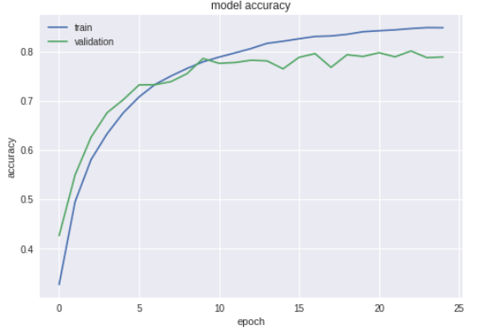

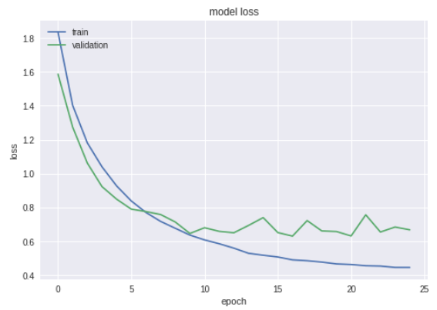

**Comments:** Model seems to overfit at the end. Now, reducing epochs and further increasing batch size.

**Experiment 8:**

No of epochs: 20

Batch size: 135

Number of layers: 2

Learning rate:0.001

Activation functions: relu

Dropout rates: 0.2

Train on 50000 samples, validate on 10000 samples

Epoch 1/20

50000/50000 [==============================] - 12s 244us/step - loss: 1.8939 - acc: 0.3066 - val_loss: 1.5474 - val_acc: 0.4325

Epoch 2/20

50000/50000 [==============================] - 11s 221us/step - loss: 1.4727 - acc: 0.4648 - val_loss: 1.3355 - val_acc: 0.5091

Epoch 3/20

50000/50000 [==============================] - 11s 221us/step - loss: 1.2632 - acc: 0.5509 - val_loss: 1.4860 - val_acc: 0.4853

Epoch 4/20

50000/50000 [==============================] - 11s 220us/step - loss: 1.1131 - acc: 0.6069 - val_loss: 1.1848 - val_acc: 0.5827

Epoch 5/20

50000/50000 [==============================] - 11s 220us/step - loss: 1.0028 - acc: 0.6463 - val_loss: 1.0277 - val_acc: 0.6418

Epoch 6/20

50000/50000 [==============================] - 11s 220us/step - loss: 0.9099 - acc: 0.6779 - val_loss: 0.9534 - val_acc: 0.6704

Epoch 7/20

50000/50000 [==============================] - 11s 221us/step - loss: 0.8409 - acc: 0.7055 - val_loss: 0.9370 - val_acc: 0.6731

Epoch 8/20

50000/50000 [==============================] - 11s 221us/step - loss: 0.7726 - acc: 0.7306 - val_loss: 0.9749 - val_acc: 0.6701

Epoch 9/20

50000/50000 [==============================] - 11s 220us/step - loss: 0.7263 - acc: 0.7463 - val_loss: 0.7594 - val_acc: 0.7381

Epoch 10/20

50000/50000 [==============================] - 11s 221us/step - loss: 0.6863 - acc: 0.7611 - val_loss: 0.7169 - val_acc: 0.7581

Epoch 11/20

50000/50000 [==============================] - 11s 220us/step - loss: 0.6465 - acc: 0.7753 - val_loss: 0.8049 - val_acc: 0.7241

Epoch 12/20

50000/50000 [==============================] - 11s 220us/step - loss: 0.6184 - acc: 0.7848 - val_loss: 0.7362 - val_acc: 0.7529

Epoch 13/20

50000/50000 [==============================] - 11s 220us/step - loss: 0.5835 - acc: 0.7959 - val_loss: 0.6880 - val_acc: 0.7691

Epoch 14/20

50000/50000 [==============================] - 11s 225us/step - loss: 0.5609 - acc: 0.8035 - val_loss: 0.6858 - val_acc: 0.7703

Epoch 15/20

50000/50000 [==============================] - 11s 220us/step - loss: 0.5381 - acc: 0.8118 - val_loss: 0.7829 - val_acc: 0.7330

Epoch 16/20

50000/50000 [==============================] - 11s 220us/step - loss: 0.5172 - acc: 0.8206 - val_loss: 0.7026 - val_acc: 0.7771

Epoch 17/20

50000/50000 [==============================] - 11s 219us/step - loss: 0.4983 - acc: 0.8272 - val_loss: 0.7402 - val_acc: 0.7614

Epoch 18/20

50000/50000 [==============================] - 11s 220us/step - loss: 0.4864 - acc: 0.8303 - val_loss: 0.6920 - val_acc: 0.7801

Epoch 19/20

50000/50000 [==============================] - 11s 221us/step - loss: 0.4707 - acc: 0.8355 - val_loss: 0.6889 - val_acc: 0.7766

Epoch 20/20

50000/50000 [==============================] - 11s 221us/step - loss: 0.4602 - acc: 0.8408 - val_loss: 0.6418 - val_acc: 0.7944

10000/10000 [==============================] - 2s 160us/step

Test loss: 0.6418456289291382

Test accuracy: 0.7944

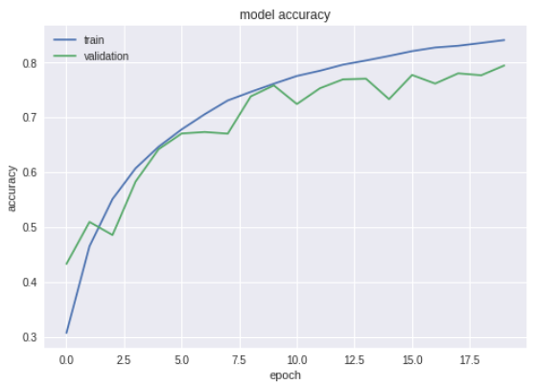

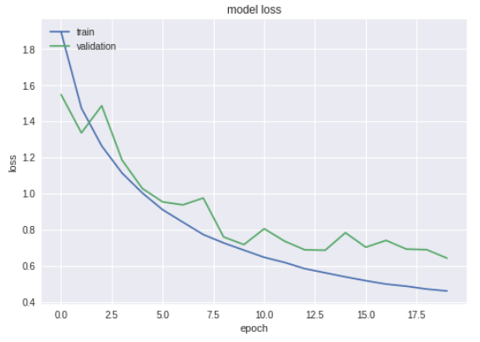

Comments: This model is also overfitting. Now changing the learning rates and dropout rates.

**Experiment 9:**

No of epochs: 20

Batch size: 135

Number of layers: 2

Learning rate:0.0001

Activation functions: relu

Dropout rates: 0.25

Train on 50000 samples, validate on 10000 samples

Epoch 1/20

50000/50000 [==============================] - 13s 258us/step - loss: 2.0743 - acc: 0.2101 - val_loss: 1.8575 - val_acc: 0.3011

Epoch 2/20

50000/50000 [==============================] - 12s 231us/step - loss: 1.8251 - acc: 0.3152 - val_loss: 1.7357 - val_acc: 0.3576

Epoch 3/20

50000/50000 [==============================] - 12s 230us/step - loss: 1.7070 - acc: 0.3673 - val_loss: 1.6477 - val_acc: 0.3988

Epoch 4/20

50000/50000 [==============================] - 11s 226us/step - loss: 1.6197 - acc: 0.4014 - val_loss: 1.6220 - val_acc: 0.4047

Epoch 5/20

50000/50000 [==============================] - 11s 227us/step - loss: 1.5537 - acc: 0.4253 - val_loss: 1.5420 - val_acc: 0.4429

Epoch 6/20

50000/50000 [==============================] - 11s 226us/step - loss: 1.5026 - acc: 0.4456 - val_loss: 1.4048 - val_acc: 0.4878

Epoch 7/20

50000/50000 [==============================] - 12s 231us/step - loss: 1.4487 - acc: 0.4703 - val_loss: 1.4159 - val_acc: 0.4815

Epoch 8/20

50000/50000 [==============================] - 11s 227us/step - loss: 1.4019 - acc: 0.4866 - val_loss: 1.3614 - val_acc: 0.5146

Epoch 9/20

50000/50000 [==============================] - 11s 226us/step - loss: 1.3615 - acc: 0.5067 - val_loss: 1.3886 - val_acc: 0.5068

Epoch 10/20

50000/50000 [==============================] - 11s 226us/step - loss: 1.3253 - acc: 0.5210 - val_loss: 1.2383 - val_acc: 0.5592

Epoch 11/20

50000/50000 [==============================] - 11s 226us/step - loss: 1.2923 - acc: 0.5351 - val_loss: 1.2553 - val_acc: 0.5513

Epoch 12/20

50000/50000 [==============================] - 11s 226us/step - loss: 1.2624 - acc: 0.5443 - val_loss: 1.2090 - val_acc: 0.5618

Epoch 13/20

50000/50000 [==============================] - 11s 227us/step - loss: 1.2357 - acc: 0.5558 - val_loss: 1.2503 - val_acc: 0.5551

Epoch 14/20

50000/50000 [==============================] - 11s 227us/step - loss: 1.2112 - acc: 0.5650 - val_loss: 1.1712 - val_acc: 0.5761

Epoch 15/20

50000/50000 [==============================] - 11s 225us/step - loss: 1.1848 - acc: 0.5752 - val_loss: 1.1399 - val_acc: 0.5895

Epoch 16/20

50000/50000 [==============================] - 11s 228us/step - loss: 1.1609 - acc: 0.5858 - val_loss: 1.1659 - val_acc: 0.5821

Epoch 17/20

50000/50000 [==============================] - 11s 226us/step - loss: 1.1434 - acc: 0.5908 - val_loss: 1.0955 - val_acc: 0.6170

Epoch 18/20

50000/50000 [==============================] - 11s 227us/step - loss: 1.1192 - acc: 0.6002 - val_loss: 1.1070 - val_acc: 0.6148

Epoch 19/20

50000/50000 [==============================] - 11s 227us/step - loss: 1.1004 - acc: 0.6059 - val_loss: 1.1152 - val_acc: 0.5982

Epoch 20/20

50000/50000 [==============================] - 11s 226us/step - loss: 1.0773 - acc: 0.6167 - val_loss: 1.1108 - val_acc: 0.6013

10000/10000 [==============================] - 2s 159us/step

Test loss: 1.1108196798324586

Test accuracy: 0.6013

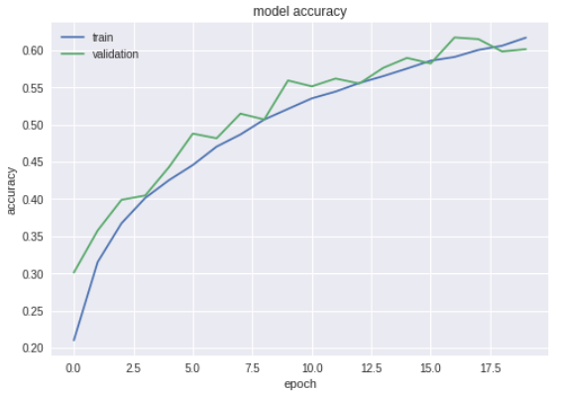

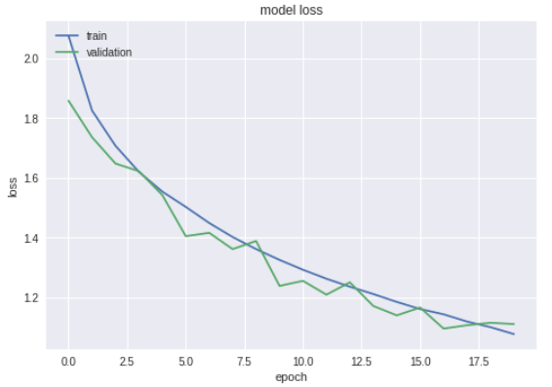

**Comments:** This is satisfactory model. We will increase batch size.

**Experiment 10:**

No of epochs: 20

Batch size: 150

Number of layers: 2

Learning rate:0.0001

Activation functions: relu

Dropout rates: 0.25

rain on 50000 samples, validate on 10000 samples

Epoch 1/20

50000/50000 [==============================] - 11s 228us/step - loss: 2.0828 - acc: 0.2094 - val_loss: 1.8563 - val_acc: 0.3105

Epoch 2/20

50000/50000 [==============================] - 10s 196us/step - loss: 1.8375 - acc: 0.3128 - val_loss: 1.7152 - val_acc: 0.3709

Epoch 3/20

50000/50000 [==============================] - 10s 196us/step - loss: 1.7487 - acc: 0.3505 - val_loss: 1.6895 - val_acc: 0.3774

Epoch 4/20

50000/50000 [==============================] - 10s 196us/step - loss: 1.6660 - acc: 0.3820 - val_loss: 1.5493 - val_acc: 0.4287

Epoch 5/20

50000/50000 [==============================] - 10s 197us/step - loss: 1.5959 - acc: 0.4100 - val_loss: 1.4858 - val_acc: 0.4507

Epoch 6/20

50000/50000 [==============================] - 10s 197us/step - loss: 1.5350 - acc: 0.4305 - val_loss: 1.4745 - val_acc: 0.4583

Epoch 7/20

50000/50000 [==============================] - 10s 197us/step - loss: 1.4938 - acc: 0.4498 - val_loss: 1.3932 - val_acc: 0.4904

Epoch 8/20

50000/50000 [==============================] - 10s 196us/step - loss: 1.4590 - acc: 0.4610 - val_loss: 1.3887 - val_acc: 0.4914

Epoch 9/20

50000/50000 [==============================] - 10s 196us/step - loss: 1.4225 - acc: 0.4805 - val_loss: 1.3228 - val_acc: 0.5178

Epoch 10/20

50000/50000 [==============================] - 10s 202us/step - loss: 1.3953 - acc: 0.4906 - val_loss: 1.3033 - val_acc: 0.5267

Epoch 11/20

50000/50000 [==============================] - 10s 197us/step - loss: 1.3627 - acc: 0.5045 - val_loss: 1.2768 - val_acc: 0.5357

Epoch 12/20

50000/50000 [==============================] - 10s 197us/step - loss: 1.3338 - acc: 0.5155 - val_loss: 1.2318 - val_acc: 0.5545

Epoch 13/20

50000/50000 [==============================] - 10s 196us/step - loss: 1.3056 - acc: 0.5261 - val_loss: 1.2757 - val_acc: 0.5394

Epoch 14/20

50000/50000 [==============================] - 10s 195us/step - loss: 1.2806 - acc: 0.5386 - val_loss: 1.2001 - val_acc: 0.5673

Epoch 15/20

50000/50000 [==============================] - 10s 196us/step - loss: 1.2562 - acc: 0.5509 - val_loss: 1.1800 - val_acc: 0.5777

Epoch 16/20

50000/50000 [==============================] - 10s 196us/step - loss: 1.2307 - acc: 0.5597 - val_loss: 1.1412 - val_acc: 0.5926

Epoch 17/20

50000/50000 [==============================] - 10s 196us/step - loss: 1.2055 - acc: 0.5678 - val_loss: 1.1376 - val_acc: 0.5904

Epoch 18/20

50000/50000 [==============================] - 10s 196us/step - loss: 1.1810 - acc: 0.5783 - val_loss: 1.1257 - val_acc: 0.5935

Epoch 19/20

50000/50000 [==============================] - 10s 195us/step - loss: 1.1658 - acc: 0.5837 - val_loss: 1.1185 - val_acc: 0.5951

Epoch 20/20

50000/50000 [==============================] - 10s 196us/step - loss: 1.1445 - acc: 0.5920 - val_loss: 1.0865 - val_acc: 0.6109

10000/10000 [==============================] - 2s 160us/step

Test loss: 1.086524907875061

Test accuracy: 0.6109

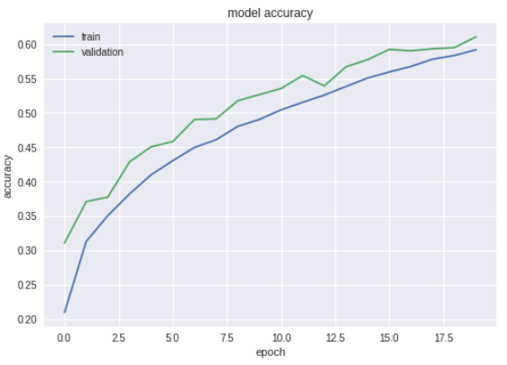

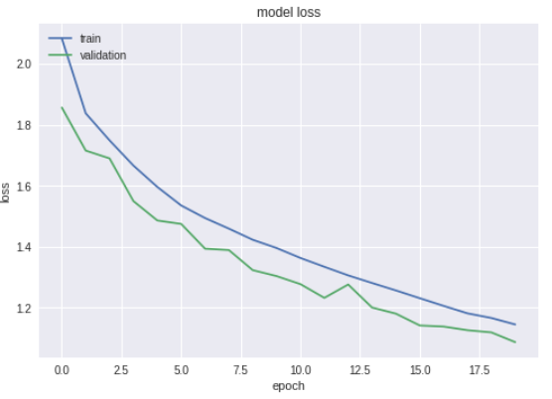

**Comments:** In this experiment, model is underfitting. Trying with different parameters.

**Experiment 11:**

No of epochs: 100

Batch size: 50

Number of layers: 2

Learning rate:0.0001

Activation functions: relu

Dropout rates: 0.25

Train on 50000 samples, validate on 10000 samples

Epoch 1/100

50000/50000 [==============================] - 17s 346us/step - loss: 1.9501 - acc: 0.2640 - val_loss: 1.6781 - val_acc: 0.3818

Epoch 2/100

50000/50000 [==============================] - 16s 317us/step - loss: 1.6392 - acc: 0.3928 - val_loss: 1.4891 - val_acc: 0.4629

Epoch 3/100

50000/50000 [==============================] - 16s 317us/step - loss: 1.4897 - acc: 0.4536 - val_loss: 1.3463 - val_acc: 0.5049

Epoch 4/100

50000/50000 [==============================] - 16s 316us/step - loss: 1.3946 - acc: 0.4927 - val_loss: 1.2767 - val_acc: 0.5330

Epoch 5/100

50000/50000 [==============================] - 16s 317us/step - loss: 1.3169 - acc: 0.5216 - val_loss: 1.2531 - val_acc: 0.5467

Epoch 6/100

50000/50000 [==============================] - 16s 317us/step - loss: 1.2563 - acc: 0.5511 - val_loss: 1.1566 - val_acc: 0.5874

Epoch 7/100

50000/50000 [==============================] - 16s 317us/step - loss: 1.1993 - acc: 0.5697 - val_loss: 1.1859 - val_acc: 0.5731

Epoch 8/100

50000/50000 [==============================] - 16s 325us/step - loss: 1.1541 - acc: 0.5894 - val_loss: 1.0709 - val_acc: 0.6214

Epoch 9/100

50000/50000 [==============================] - 16s 319us/step - loss: 1.1142 - acc: 0.6028 - val_loss: 1.0339 - val_acc: 0.6313

Epoch 10/100

50000/50000 [==============================] - 16s 317us/step - loss: 1.0771 - acc: 0.6171 - val_loss: 1.0398 - val_acc: 0.6313

Epoch 11/100

50000/50000 [==============================] - 16s 315us/step - loss: 1.0446 - acc: 0.6286 - val_loss: 0.9854 - val_acc: 0.6511

Epoch 12/100

50000/50000 [==============================] - 16s 316us/step - loss: 1.0120 - acc: 0.6406 - val_loss: 0.9834 - val_acc: 0.6451

Epoch 13/100

50000/50000 [==============================] - 16s 315us/step - loss: 0.9821 - acc: 0.6516 - val_loss: 0.9210 - val_acc: 0.6750

Epoch 14/100

50000/50000 [==============================] - 16s 316us/step - loss: 0.9541 - acc: 0.6611 - val_loss: 0.9114 - val_acc: 0.6799

Epoch 15/100

50000/50000 [==============================] - 16s 315us/step - loss: 0.9280 - acc: 0.6713 - val_loss: 0.8859 - val_acc: 0.6869

Epoch 16/100

50000/50000 [==============================] - 16s 315us/step - loss: 0.9064 - acc: 0.6773 - val_loss: 0.8900 - val_acc: 0.6888

Epoch 17/100

50000/50000 [==============================] - 16s 315us/step - loss: 0.8809 - acc: 0.6869 - val_loss: 0.8411 - val_acc: 0.7047

Epoch 18/100

50000/50000 [==============================] - 16s 322us/step - loss: 0.8590 - acc: 0.6967 - val_loss: 0.8725 - val_acc: 0.6914

Epoch 19/100

50000/50000 [==============================] - 16s 315us/step - loss: 0.8388 - acc: 0.7021 - val_loss: 0.7996 - val_acc: 0.7165

Epoch 20/100

50000/50000 [==============================] - 16s 315us/step - loss: 0.8218 - acc: 0.7088 - val_loss: 0.8483 - val_acc: 0.7038

Epoch 21/100

50000/50000 [==============================] - 16s 315us/step - loss: 0.8005 - acc: 0.7184 - val_loss: 0.7580 - val_acc: 0.7310

Epoch 22/100

50000/50000 [==============================] - 16s 315us/step - loss: 0.7836 - acc: 0.7236 - val_loss: 0.7496 - val_acc: 0.7374

Epoch 23/100

50000/50000 [==============================] - 16s 313us/step - loss: 0.7658 - acc: 0.7316 - val_loss: 0.7464 - val_acc: 0.7397

Epoch 24/100

50000/50000 [==============================] - 16s 312us/step - loss: 0.7497 - acc: 0.7377 - val_loss: 0.7286 - val_acc: 0.7430

Epoch 25/100

50000/50000 [==============================] - 16s 312us/step - loss: 0.7360 - acc: 0.7419 - val_loss: 0.7538 - val_acc: 0.7356

Epoch 26/100

50000/50000 [==============================] - 16s 314us/step - loss: 0.7211 - acc: 0.7461 - val_loss: 0.7478 - val_acc: 0.7389

Epoch 27/100

50000/50000 [==============================] - 16s 314us/step - loss: 0.7079 - acc: 0.7534 - val_loss: 0.6927 - val_acc: 0.7592

Epoch 28/100

50000/50000 [==============================] - 16s 327us/step - loss: 0.6966 - acc: 0.7569 - val_loss: 0.6882 - val_acc: 0.7606

Epoch 29/100

50000/50000 [==============================] - 16s 313us/step - loss: 0.6800 - acc: 0.7611 - val_loss: 0.6863 - val_acc: 0.7604

Epoch 30/100

50000/50000 [==============================] - 16s 313us/step - loss: 0.6704 - acc: 0.7650 - val_loss: 0.6927 - val_acc: 0.7582

Epoch 31/100

50000/50000 [==============================] - 16s 315us/step - loss: 0.6565 - acc: 0.7690 - val_loss: 0.6649 - val_acc: 0.7680

Epoch 32/100

50000/50000 [==============================] - 16s 314us/step - loss: 0.6463 - acc: 0.7732 - val_loss: 0.7118 - val_acc: 0.7533

Epoch 33/100

50000/50000 [==============================] - 16s 315us/step - loss: 0.6367 - acc: 0.7761 - val_loss: 0.6849 - val_acc: 0.7625

Epoch 34/100

50000/50000 [==============================] - 16s 315us/step - loss: 0.6284 - acc: 0.7794 - val_loss: 0.6575 - val_acc: 0.7739

Epoch 35/100

50000/50000 [==============================] - 16s 315us/step - loss: 0.6206 - acc: 0.7823 - val_loss: 0.6429 - val_acc: 0.7776

Epoch 36/100

50000/50000 [==============================] - 16s 317us/step - loss: 0.6071 - acc: 0.7845 - val_loss: 0.6464 - val_acc: 0.7757

Epoch 37/100

50000/50000 [==============================] - 16s 322us/step - loss: 0.5986 - acc: 0.7889 - val_loss: 0.6569 - val_acc: 0.7734

Epoch 38/100

50000/50000 [==============================] - 16s 314us/step - loss: 0.5899 - acc: 0.7928 - val_loss: 0.6697 - val_acc: 0.7691

Epoch 39/100

50000/50000 [==============================] - 16s 314us/step - loss: 0.5804 - acc: 0.7942 - val_loss: 0.6294 - val_acc: 0.7850

Epoch 40/100

50000/50000 [==============================] - 16s 314us/step - loss: 0.5759 - acc: 0.7974 - val_loss: 0.6296 - val_acc: 0.7844

Epoch 41/100

50000/50000 [==============================] - 16s 315us/step - loss: 0.5664 - acc: 0.8001 - val_loss: 0.6210 - val_acc: 0.7863

Epoch 42/100

50000/50000 [==============================] - 16s 313us/step - loss: 0.5619 - acc: 0.8020 - val_loss: 0.6148 - val_acc: 0.7919

Epoch 43/100

50000/50000 [==============================] - 16s 312us/step - loss: 0.5498 - acc: 0.8060 - val_loss: 0.6151 - val_acc: 0.7886

Epoch 44/100

50000/50000 [==============================] - 16s 313us/step - loss: 0.5416 - acc: 0.8108 - val_loss: 0.6128 - val_acc: 0.7908

Epoch 45/100

50000/50000 [==============================] - 16s 313us/step - loss: 0.5360 - acc: 0.8109 - val_loss: 0.6051 - val_acc: 0.7957

Epoch 46/100

50000/50000 [==============================] - 16s 313us/step - loss: 0.5339 - acc: 0.8115 - val_loss: 0.6059 - val_acc: 0.7932

Epoch 47/100

50000/50000 [==============================] - 16s 313us/step - loss: 0.5269 - acc: 0.8154 - val_loss: 0.6193 - val_acc: 0.7861

Epoch 48/100

50000/50000 [==============================] - 16s 323us/step - loss: 0.5191 - acc: 0.8168 - val_loss: 0.6082 - val_acc: 0.7934

Epoch 49/100

50000/50000 [==============================] - 16s 311us/step - loss: 0.5123 - acc: 0.8187 - val_loss: 0.5942 - val_acc: 0.7969

Epoch 50/100

50000/50000 [==============================] - 16s 312us/step - loss: 0.5060 - acc: 0.8214 - val_loss: 0.5995 - val_acc: 0.7927

Epoch 51/100

50000/50000 [==============================] - 16s 311us/step - loss: 0.5019 - acc: 0.8224 - val_loss: 0.6097 - val_acc: 0.7948

Epoch 52/100

50000/50000 [==============================] - 16s 310us/step - loss: 0.4972 - acc: 0.8243 - val_loss: 0.5985 - val_acc: 0.7981

Epoch 53/100

50000/50000 [==============================] - 15s 310us/step - loss: 0.4902 - acc: 0.8278 - val_loss: 0.6356 - val_acc: 0.7893

Epoch 54/100

50000/50000 [==============================] - 16s 314us/step - loss: 0.4872 - acc: 0.8286 - val_loss: 0.5771 - val_acc: 0.8037

Epoch 55/100

50000/50000 [==============================] - 16s 315us/step - loss: 0.4797 - acc: 0.8309 - val_loss: 0.5996 - val_acc: 0.7974

Epoch 56/100

50000/50000 [==============================] - 16s 316us/step - loss: 0.4767 - acc: 0.8326 - val_loss: 0.6207 - val_acc: 0.7912

Epoch 57/100

50000/50000 [==============================] - 16s 324us/step - loss: 0.4658 - acc: 0.8368 - val_loss: 0.5954 - val_acc: 0.8020

Epoch 58/100

50000/50000 [==============================] - 16s 322us/step - loss: 0.4596 - acc: 0.8391 - val_loss: 0.6149 - val_acc: 0.7980

Epoch 59/100

50000/50000 [==============================] - 16s 318us/step - loss: 0.4553 - acc: 0.8384 - val_loss: 0.5769 - val_acc: 0.8058

Epoch 60/100

50000/50000 [==============================] - 16s 319us/step - loss: 0.4557 - acc: 0.8404 - val_loss: 0.5819 - val_acc: 0.8029

Epoch 61/100

50000/50000 [==============================] - 16s 317us/step - loss: 0.4493 - acc: 0.8422 - val_loss: 0.5717 - val_acc: 0.8058

Epoch 62/100

50000/50000 [==============================] - 16s 318us/step - loss: 0.4462 - acc: 0.8438 - val_loss: 0.5745 - val_acc: 0.8064

Epoch 63/100

50000/50000 [==============================] - 16s 317us/step - loss: 0.4393 - acc: 0.8440 - val_loss: 0.5719 - val_acc: 0.8070

Epoch 64/100

50000/50000 [==============================] - 16s 317us/step - loss: 0.4366 - acc: 0.8469 - val_loss: 0.5645 - val_acc: 0.8101

Epoch 65/100

50000/50000 [==============================] - 16s 317us/step - loss: 0.4357 - acc: 0.8464 - val_loss: 0.5706 - val_acc: 0.8068

Epoch 66/100

50000/50000 [==============================] - 16s 316us/step - loss: 0.4304 - acc: 0.8480 - val_loss: 0.5844 - val_acc: 0.8050

Epoch 67/100

50000/50000 [==============================] - 16s 326us/step - loss: 0.4238 - acc: 0.8518 - val_loss: 0.5799 - val_acc: 0.8046

Epoch 68/100

50000/50000 [==============================] - 16s 317us/step - loss: 0.4217 - acc: 0.8501 - val_loss: 0.5943 - val_acc: 0.8020

Epoch 69/100

50000/50000 [==============================] - 16s 316us/step - loss: 0.4175 - acc: 0.8537 - val_loss: 0.5674 - val_acc: 0.8075

Epoch 70/100

50000/50000 [==============================] - 16s 316us/step - loss: 0.4141 - acc: 0.8544 - val_loss: 0.5768 - val_acc: 0.8073

Epoch 71/100

50000/50000 [==============================] - 16s 315us/step - loss: 0.4084 - acc: 0.8557 - val_loss: 0.5907 - val_acc: 0.8064

Epoch 72/100

50000/50000 [==============================] - 16s 314us/step - loss: 0.4042 - acc: 0.8591 - val_loss: 0.5822 - val_acc: 0.8072

Epoch 73/100

50000/50000 [==============================] - 16s 314us/step - loss: 0.3994 - acc: 0.8596 - val_loss: 0.5878 - val_acc: 0.7994

Epoch 74/100

50000/50000 [==============================] - 16s 315us/step - loss: 0.4000 - acc: 0.8590 - val_loss: 0.5713 - val_acc: 0.8074

Epoch 75/100

50000/50000 [==============================] - 16s 315us/step - loss: 0.3967 - acc: 0.8599 - val_loss: 0.5808 - val_acc: 0.8080

Epoch 76/100

50000/50000 [==============================] - 16s 321us/step - loss: 0.3906 - acc: 0.8614 - val_loss: 0.5707 - val_acc: 0.8117

Epoch 77/100

50000/50000 [==============================] - 16s 315us/step - loss: 0.3872 - acc: 0.8648 - val_loss: 0.5929 - val_acc: 0.8069

Epoch 78/100

50000/50000 [==============================] - 16s 317us/step - loss: 0.3864 - acc: 0.8650 - val_loss: 0.5823 - val_acc: 0.8105

Epoch 79/100

50000/50000 [==============================] - 16s 318us/step - loss: 0.3789 - acc: 0.8662 - val_loss: 0.6162 - val_acc: 0.8025

Epoch 80/100

50000/50000 [==============================] - 16s 317us/step - loss: 0.3763 - acc: 0.8664 - val_loss: 0.5890 - val_acc: 0.8065

Epoch 81/100

50000/50000 [==============================] - 16s 317us/step - loss: 0.3791 - acc: 0.8661 - val_loss: 0.5870 - val_acc: 0.8089

Epoch 82/100

50000/50000 [==============================] - 16s 315us/step - loss: 0.3746 - acc: 0.8693 - val_loss: 0.5709 - val_acc: 0.8130

Epoch 83/100

50000/50000 [==============================] - 16s 316us/step - loss: 0.3718 - acc: 0.8679 - val_loss: 0.5945 - val_acc: 0.8092

Epoch 84/100

50000/50000 [==============================] - 16s 315us/step - loss: 0.3715 - acc: 0.8695 - val_loss: 0.5567 - val_acc: 0.8138

Epoch 85/100

50000/50000 [==============================] - 16s 314us/step - loss: 0.3667 - acc: 0.8705 - val_loss: 0.6341 - val_acc: 0.8042

Epoch 86/100

50000/50000 [==============================] - 16s 315us/step - loss: 0.3609 - acc: 0.8734 - val_loss: 0.5912 - val_acc: 0.8061

Epoch 87/100

50000/50000 [==============================] - 16s 326us/step - loss: 0.3573 - acc: 0.8736 - val_loss: 0.5857 - val_acc: 0.8133

Epoch 88/100

50000/50000 [==============================] - 16s 312us/step - loss: 0.3549 - acc: 0.8744 - val_loss: 0.5755 - val_acc: 0.8108

Epoch 89/100

50000/50000 [==============================] - 16s 312us/step - loss: 0.3491 - acc: 0.8768 - val_loss: 0.5987 - val_acc: 0.8040

Epoch 90/100

50000/50000 [==============================] - 16s 311us/step - loss: 0.3435 - acc: 0.8787 - val_loss: 0.5941 - val_acc: 0.8117

Epoch 91/100

50000/50000 [==============================] - 16s 312us/step - loss: 0.3487 - acc: 0.8774 - val_loss: 0.5828 - val_acc: 0.8150

Epoch 92/100

50000/50000 [==============================] - 16s 311us/step - loss: 0.3468 - acc: 0.8799 - val_loss: 0.6078 - val_acc: 0.8057

Epoch 93/100

50000/50000 [==============================] - 16s 312us/step - loss: 0.3467 - acc: 0.8767 - val_loss: 0.6010 - val_acc: 0.8077

Epoch 94/100

50000/50000 [==============================] - 16s 312us/step - loss: 0.3430 - acc: 0.8783 - val_loss: 0.5718 - val_acc: 0.8156

Epoch 95/100

50000/50000 [==============================] - 16s 321us/step - loss: 0.3383 - acc: 0.8803 - val_loss: 0.6306 - val_acc: 0.8047

Epoch 96/100

50000/50000 [==============================] - 16s 313us/step - loss: 0.3401 - acc: 0.8808 - val_loss: 0.5870 - val_acc: 0.8105

Epoch 97/100

50000/50000 [==============================] - 16s 312us/step - loss: 0.3360 - acc: 0.8812 - val_loss: 0.5808 - val_acc: 0.8142

Epoch 98/100

50000/50000 [==============================] - 16s 313us/step - loss: 0.3356 - acc: 0.8812 - val_loss: 0.6013 - val_acc: 0.8119

Epoch 99/100

50000/50000 [==============================] - 16s 313us/step - loss: 0.3266 - acc: 0.8847 - val_loss: 0.6085 - val_acc: 0.8109

Epoch 100/100

50000/50000 [==============================] - 16s 313us/step - loss: 0.3270 - acc: 0.8843 - val_loss: 0.6030 - val_acc: 0.8079

10000/10000 [==============================] - 2s 159us/step

Test loss: 0.6030027280330658

Test accuracy: 0.8079

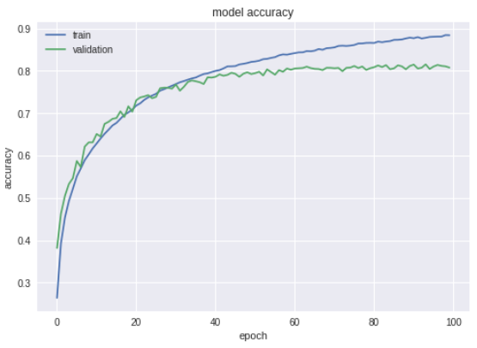

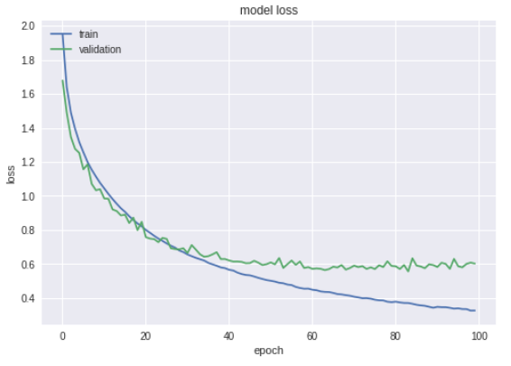

**Comments:** Model is overfitting. Reducing epochs.

**Experiment 12:**

No of epochs: 34

Batch size: 50

Number of layers: 2

Learning rate:0.0001

Activation functions: relu

Dropout rates: 0.25

Train on 50000 samples, validate on 10000 samples

Epoch 1/34

50000/50000 [==============================] - 17s 348us/step - loss: 1.9491 - acc: 0.2632 - val_loss: 1.7282 - val_acc: 0.3503

Epoch 2/34

50000/50000 [==============================] - 16s 313us/step - loss: 1.6747 - acc: 0.3788 - val_loss: 1.5185 - val_acc: 0.4391

Epoch 3/34

50000/50000 [==============================] - 16s 314us/step - loss: 1.5386 - acc: 0.4330 - val_loss: 1.4784 - val_acc: 0.4581

Epoch 4/34

50000/50000 [==============================] - 16s 316us/step - loss: 1.4402 - acc: 0.4728 - val_loss: 1.3362 - val_acc: 0.5172

Epoch 5/34

50000/50000 [==============================] - 16s 316us/step - loss: 1.3566 - acc: 0.5074 - val_loss: 1.2874 - val_acc: 0.5282

Epoch 6/34

50000/50000 [==============================] - 16s 315us/step - loss: 1.2907 - acc: 0.5345 - val_loss: 1.1909 - val_acc: 0.5751

Epoch 7/34

50000/50000 [==============================] - 16s 326us/step - loss: 1.2279 - acc: 0.5587 - val_loss: 1.1314 - val_acc: 0.5901

Epoch 8/34

50000/50000 [==============================] - 16s 315us/step - loss: 1.1774 - acc: 0.5787 - val_loss: 1.1245 - val_acc: 0.5926

Epoch 9/34

50000/50000 [==============================] - 16s 315us/step - loss: 1.1318 - acc: 0.5941 - val_loss: 1.1222 - val_acc: 0.5947

Epoch 10/34

50000/50000 [==============================] - 16s 315us/step - loss: 1.0921 - acc: 0.6101 - val_loss: 1.0163 - val_acc: 0.6375

Epoch 11/34

50000/50000 [==============================] - 16s 315us/step - loss: 1.0553 - acc: 0.6240 - val_loss: 0.9838 - val_acc: 0.6535

Epoch 12/34

50000/50000 [==============================] - 16s 315us/step - loss: 1.0193 - acc: 0.6364 - val_loss: 0.9587 - val_acc: 0.6585

Epoch 13/34

50000/50000 [==============================] - 16s 315us/step - loss: 0.9896 - acc: 0.6495 - val_loss: 0.9519 - val_acc: 0.6615

Epoch 14/34

50000/50000 [==============================] - 16s 320us/step - loss: 0.9629 - acc: 0.6583 - val_loss: 0.9198 - val_acc: 0.6748

Epoch 15/34

50000/50000 [==============================] - 16s 317us/step - loss: 0.9392 - acc: 0.6688 - val_loss: 0.8738 - val_acc: 0.6901

Epoch 16/34

50000/50000 [==============================] - 16s 316us/step - loss: 0.9147 - acc: 0.6757 - val_loss: 0.8625 - val_acc: 0.6928

Epoch 17/34

50000/50000 [==============================] - 16s 315us/step - loss: 0.8940 - acc: 0.6827 - val_loss: 0.8570 - val_acc: 0.6956

Epoch 18/34

50000/50000 [==============================] - 16s 316us/step - loss: 0.8716 - acc: 0.6903 - val_loss: 0.8450 - val_acc: 0.7029

Epoch 19/34

50000/50000 [==============================] - 16s 317us/step - loss: 0.8493 - acc: 0.6973 - val_loss: 0.8103 - val_acc: 0.7181

Epoch 20/34

50000/50000 [==============================] - 16s 316us/step - loss: 0.8330 - acc: 0.7056 - val_loss: 0.8849 - val_acc: 0.6833

Epoch 21/34

50000/50000 [==============================] - 16s 316us/step - loss: 0.8122 - acc: 0.7123 - val_loss: 0.7875 - val_acc: 0.7220

Epoch 22/34

50000/50000 [==============================] - 16s 317us/step - loss: 0.7970 - acc: 0.7160 - val_loss: 0.7798 - val_acc: 0.7288

Epoch 23/34

50000/50000 [==============================] - 16s 317us/step - loss: 0.7761 - acc: 0.7262 - val_loss: 0.7684 - val_acc: 0.7313

Epoch 24/34

50000/50000 [==============================] - 16s 318us/step - loss: 0.7578 - acc: 0.7307 - val_loss: 0.7444 - val_acc: 0.7389

Epoch 25/34

50000/50000 [==============================] - 16s 316us/step - loss: 0.7462 - acc: 0.7363 - val_loss: 0.7421 - val_acc: 0.7430

Epoch 26/34

50000/50000 [==============================] - 16s 323us/step - loss: 0.7320 - acc: 0.7412 - val_loss: 0.7190 - val_acc: 0.7516

Epoch 27/34

50000/50000 [==============================] - 16s 319us/step - loss: 0.7160 - acc: 0.7463 - val_loss: 0.7159 - val_acc: 0.7472

Epoch 28/34

50000/50000 [==============================] - 16s 316us/step - loss: 0.6993 - acc: 0.7534 - val_loss: 0.7078 - val_acc: 0.7541

Epoch 29/34

50000/50000 [==============================] - 16s 316us/step - loss: 0.6859 - acc: 0.7573 - val_loss: 0.6951 - val_acc: 0.7546

Epoch 30/34

50000/50000 [==============================] - 16s 315us/step - loss: 0.6728 - acc: 0.7635 - val_loss: 0.7082 - val_acc: 0.7551

Epoch 31/34

50000/50000 [==============================] - 16s 315us/step - loss: 0.6615 - acc: 0.7657 - val_loss: 0.6901 - val_acc: 0.7655

Epoch 32/34

50000/50000 [==============================] - 16s 315us/step - loss: 0.6582 - acc: 0.7687 - val_loss: 0.6706 - val_acc: 0.7703

Epoch 33/34

50000/50000 [==============================] - 16s 316us/step - loss: 0.6429 - acc: 0.7743 - val_loss: 0.6724 - val_acc: 0.7685

Epoch 34/34

50000/50000 [==============================] - 16s 320us/step - loss: 0.6349 - acc: 0.7756 - val_loss: 0.6625 - val_acc: 0.7736

10000/10000 [==============================] - 2s 168us/step

Test loss: 0.6625150304317474

Test accuracy: 0.7736

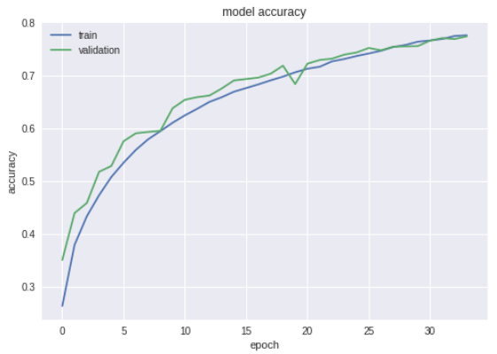

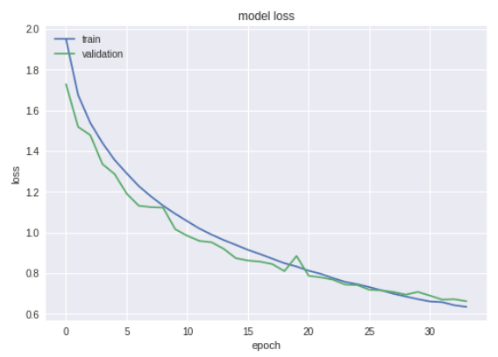

**Comments:** This is the best model so far.

**Conclusion:**

After conducting several experiments, we can conclude that Experiment number 12 is the best model. It is because that model is neither underfitting or overfitting.

The parameter values for best model are:

No of epochs: 34

Batch size: 50

Number of layers: 2

Learning rate:0.0001

Activation functions: relu

Dropout rates: 0.25

We can further do more experiments by changing values of parameters such as number of layers, epochs, batch size etc. to improve our model.

**Changes in padding and strides**

**Experiment 1:**

No of epochs: 34

Batch size: 50

Number of layers: 2

Learning rate:0.0001

Activation functions: relu

Dropout rates: 0.25

Padding: Valid

Strides: 2

Train on 50000 samples, validate on 10000 samples

Epoch 1/34

50000/50000 [==============================] - 18s 365us/step - loss: 1.7842 - acc: 0.3503 - val_loss: 1.5438 - val_acc: 0.4462

Epoch 2/34

50000/50000 [==============================] - 14s 274us/step - loss: 1.4971 - acc: 0.4541 - val_loss: 1.3696 - val_acc: 0.5069

Epoch 3/34

50000/50000 [==============================] - 14s 270us/step - loss: 1.3766 - acc: 0.5022 - val_loss: 1.3264 - val_acc: 0.5255

Epoch 4/34

50000/50000 [==============================] - 14s 272us/step - loss: 1.2898 - acc: 0.5419 - val_loss: 1.2166 - val_acc: 0.5700

Epoch 5/34

50000/50000 [==============================] - 14s 271us/step - loss: 1.2160 - acc: 0.5675 - val_loss: 1.1400 - val_acc: 0.6002

Epoch 6/34

50000/50000 [==============================] - 13s 269us/step - loss: 1.1557 - acc: 0.5900 - val_loss: 1.1447 - val_acc: 0.5922

Epoch 7/34

50000/50000 [==============================] - 14s 271us/step - loss: 1.1047 - acc: 0.6113 - val_loss: 1.0419 - val_acc: 0.6374

Epoch 8/34

50000/50000 [==============================] - 13s 269us/step - loss: 1.0614 - acc: 0.6285 - val_loss: 1.0052 - val_acc: 0.6499

Epoch 9/34

50000/50000 [==============================] - 14s 273us/step - loss: 1.0201 - acc: 0.6429 - val_loss: 0.9934 - val_acc: 0.6568

Epoch 10/34

50000/50000 [==============================] - 14s 274us/step - loss: 0.9858 - acc: 0.6560 - val_loss: 0.9594 - val_acc: 0.6682

Epoch 11/34

50000/50000 [==============================] - 13s 269us/step - loss: 0.9536 - acc: 0.6684 - val_loss: 0.9289 - val_acc: 0.6792

Epoch 12/34

50000/50000 [==============================] - 14s 270us/step - loss: 0.9264 - acc: 0.6751 - val_loss: 0.9070 - val_acc: 0.6876

Epoch 13/34

50000/50000 [==============================] - 13s 269us/step - loss: 0.8930 - acc: 0.6889 - val_loss: 0.8781 - val_acc: 0.6990

Epoch 14/34

50000/50000 [==============================] - 13s 269us/step - loss: 0.8642 - acc: 0.7005 - val_loss: 0.8622 - val_acc: 0.7052

Epoch 15/34

50000/50000 [==============================] - 13s 270us/step - loss: 0.8405 - acc: 0.7095 - val_loss: 0.8765 - val_acc: 0.6987

Epoch 16/34

50000/50000 [==============================] - 13s 270us/step - loss: 0.8156 - acc: 0.7176 - val_loss: 0.8333 - val_acc: 0.7129

Epoch 17/34

50000/50000 [==============================] - 13s 270us/step - loss: 0.7878 - acc: 0.7262 - val_loss: 0.8228 - val_acc: 0.7167

Epoch 18/34

50000/50000 [==============================] - 14s 271us/step - loss: 0.7696 - acc: 0.7336 - val_loss: 0.8075 - val_acc: 0.7234

Epoch 19/34

50000/50000 [==============================] - 13s 269us/step - loss: 0.7478 - acc: 0.7405 - val_loss: 0.8040 - val_acc: 0.7218

Epoch 20/34

50000/50000 [==============================] - 13s 269us/step - loss: 0.7280 - acc: 0.7457 - val_loss: 0.7728 - val_acc: 0.7331

Epoch 21/34

50000/50000 [==============================] - 13s 269us/step - loss: 0.7106 - acc: 0.7538 - val_loss: 0.8271 - val_acc: 0.7136

Epoch 22/34

50000/50000 [==============================] - 13s 270us/step - loss: 0.6938 - acc: 0.7604 - val_loss: 0.7824 - val_acc: 0.7318

Epoch 23/34

50000/50000 [==============================] - 13s 269us/step - loss: 0.6773 - acc: 0.7658 - val_loss: 0.7677 - val_acc: 0.7348

Epoch 24/34

50000/50000 [==============================] - 14s 273us/step - loss: 0.6591 - acc: 0.7725 - val_loss: 0.7343 - val_acc: 0.7491

Epoch 25/34

50000/50000 [==============================] - 13s 269us/step - loss: 0.6418 - acc: 0.7799 - val_loss: 0.7331 - val_acc: 0.7482

Epoch 26/34

50000/50000 [==============================] - 13s 270us/step - loss: 0.6292 - acc: 0.7828 - val_loss: 0.7145 - val_acc: 0.7568

Epoch 27/34

50000/50000 [==============================] - 13s 270us/step - loss: 0.6176 - acc: 0.7863 - val_loss: 0.7118 - val_acc: 0.7554

Epoch 28/34

50000/50000 [==============================] - 13s 269us/step - loss: 0.6021 - acc: 0.7917 - val_loss: 0.7299 - val_acc: 0.7533

Epoch 29/34

50000/50000 [==============================] - 13s 268us/step - loss: 0.5890 - acc: 0.7971 - val_loss: 0.7082 - val_acc: 0.7582

Epoch 30/34

50000/50000 [==============================] - 13s 267us/step - loss: 0.5720 - acc: 0.8037 - val_loss: 0.6999 - val_acc: 0.7618

Epoch 31/34

50000/50000 [==============================] - 13s 268us/step - loss: 0.5650 - acc: 0.8054 - val_loss: 0.6979 - val_acc: 0.7607

Epoch 32/34

50000/50000 [==============================] - 14s 271us/step - loss: 0.5504 - acc: 0.8093 - val_loss: 0.6987 - val_acc: 0.7616

Epoch 33/34

50000/50000 [==============================] - 14s 271us/step - loss: 0.5426 - acc: 0.8119 - val_loss: 0.7180 - val_acc: 0.7584

Epoch 34/34

50000/50000 [==============================] - 13s 267us/step - loss: 0.5335 - acc: 0.8178 - val_loss: 0.6838 - val_acc: 0.7687

10000/10000 [==============================] - 1s 137us/step

Test loss: 0.6838360221862793

Test accuracy: 0.7688

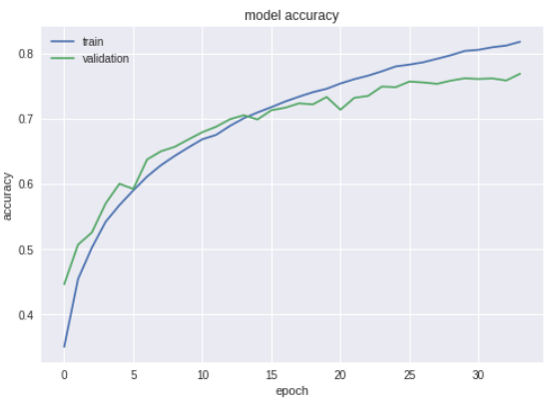

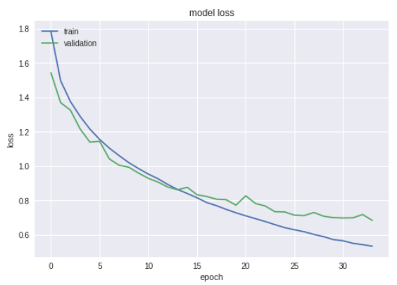

**Experiment 2:**

No of epochs: 34

Batch size: 50

Number of layers: 2

Learning rate:0.0001

Activation functions: relu

Dropout rates: 0.25

Padding: same

Strides: 2

Train on 50000 samples, validate on 10000 samples

Epoch 1/34

50000/50000 [==============================] - 16s 328us/step - loss: 1.7433 - acc: 0.3722 - val_loss: 1.4977 - val_acc: 0.4667

Epoch 2/34

50000/50000 [==============================] - 15s 308us/step - loss: 1.4500 - acc: 0.4776 - val_loss: 1.3267 - val_acc: 0.5243

Epoch 3/34

50000/50000 [==============================] - 15s 308us/step - loss: 1.3082 - acc: 0.5342 - val_loss: 1.2258 - val_acc: 0.5623

Epoch 4/34

50000/50000 [==============================] - 15s 309us/step - loss: 1.2052 - acc: 0.5746 - val_loss: 1.1297 - val_acc: 0.6026

Epoch 5/34

50000/50000 [==============================] - 15s 305us/step - loss: 1.1187 - acc: 0.6075 - val_loss: 1.0552 - val_acc: 0.6280

Epoch 6/34

50000/50000 [==============================] - 15s 305us/step - loss: 1.0523 - acc: 0.6315 - val_loss: 1.0064 - val_acc: 0.6475

Epoch 7/34

50000/50000 [==============================] - 15s 308us/step - loss: 0.9965 - acc: 0.6534 - val_loss: 0.9598 - val_acc: 0.6613

Epoch 8/34

50000/50000 [==============================] - 15s 304us/step - loss: 0.9460 - acc: 0.6674 - val_loss: 0.9254 - val_acc: 0.6764

Epoch 9/34

50000/50000 [==============================] - 15s 305us/step - loss: 0.9050 - acc: 0.6830 - val_loss: 0.8884 - val_acc: 0.6889

Epoch 10/34

50000/50000 [==============================] - 15s 305us/step - loss: 0.8650 - acc: 0.6996 - val_loss: 0.8592 - val_acc: 0.6998

Epoch 11/34

50000/50000 [==============================] - 15s 305us/step - loss: 0.8304 - acc: 0.7115 - val_loss: 0.8241 - val_acc: 0.7139

Epoch 12/34

50000/50000 [==============================] - 15s 305us/step - loss: 0.7983 - acc: 0.7217 - val_loss: 0.8078 - val_acc: 0.7230

Epoch 13/34

50000/50000 [==============================] - 15s 305us/step - loss: 0.7709 - acc: 0.7336 - val_loss: 0.7815 - val_acc: 0.7337

Epoch 14/34

50000/50000 [==============================] - 15s 306us/step - loss: 0.7425 - acc: 0.7423 - val_loss: 0.8224 - val_acc: 0.7141

Epoch 15/34

50000/50000 [==============================] - 15s 309us/step - loss: 0.7142 - acc: 0.7529 - val_loss: 0.7768 - val_acc: 0.7331

Epoch 16/34

50000/50000 [==============================] - 15s 306us/step - loss: 0.6913 - acc: 0.7615 - val_loss: 0.7713 - val_acc: 0.7384

Epoch 17/34

50000/50000 [==============================] - 15s 306us/step - loss: 0.6709 - acc: 0.7687 - val_loss: 0.7515 - val_acc: 0.7395

Epoch 18/34

50000/50000 [==============================] - 15s 307us/step - loss: 0.6438 - acc: 0.7755 - val_loss: 0.7150 - val_acc: 0.7544

Epoch 19/34

50000/50000 [==============================] - 15s 307us/step - loss: 0.6256 - acc: 0.7820 - val_loss: 0.6987 - val_acc: 0.7644

Epoch 20/34

50000/50000 [==============================] - 15s 307us/step - loss: 0.6071 - acc: 0.7889 - val_loss: 0.6910 - val_acc: 0.7631

Epoch 21/34

50000/50000 [==============================] - 15s 305us/step - loss: 0.5877 - acc: 0.7956 - val_loss: 0.6881 - val_acc: 0.7646

Epoch 22/34

50000/50000 [==============================] - 15s 307us/step - loss: 0.5701 - acc: 0.8035 - val_loss: 0.7103 - val_acc: 0.7604

Epoch 23/34

50000/50000 [==============================] - 15s 306us/step - loss: 0.5546 - acc: 0.8073 - val_loss: 0.6822 - val_acc: 0.7684

Epoch 24/34

50000/50000 [==============================] - 15s 304us/step - loss: 0.5376 - acc: 0.8145 - val_loss: 0.6726 - val_acc: 0.7711

Epoch 25/34

50000/50000 [==============================] - 15s 305us/step - loss: 0.5237 - acc: 0.8190 - val_loss: 0.6792 - val_acc: 0.7665

Epoch 26/34

50000/50000 [==============================] - 15s 305us/step - loss: 0.5059 - acc: 0.8256 - val_loss: 0.6613 - val_acc: 0.7787

Epoch 27/34

50000/50000 [==============================] - 15s 309us/step - loss: 0.4980 - acc: 0.8272 - val_loss: 0.6889 - val_acc: 0.7718

Epoch 28/34

50000/50000 [==============================] - 15s 305us/step - loss: 0.4804 - acc: 0.8327 - val_loss: 0.6736 - val_acc: 0.7726

Epoch 29/34

50000/50000 [==============================] - 15s 304us/step - loss: 0.4709 - acc: 0.8390 - val_loss: 0.6710 - val_acc: 0.7817

Epoch 30/34

50000/50000 [==============================] - 15s 304us/step - loss: 0.4568 - acc: 0.8441 - val_loss: 0.6538 - val_acc: 0.7801

Epoch 31/34

50000/50000 [==============================] - 15s 304us/step - loss: 0.4509 - acc: 0.8447 - val_loss: 0.6691 - val_acc: 0.7814

Epoch 32/34

50000/50000 [==============================] - 15s 303us/step - loss: 0.4406 - acc: 0.8482 - val_loss: 0.6553 - val_acc: 0.7868

Epoch 33/34

50000/50000 [==============================] - 15s 304us/step - loss: 0.4299 - acc: 0.8514 - val_loss: 0.6407 - val_acc: 0.7884

Epoch 34/34

50000/50000 [==============================] - 15s 304us/step - loss: 0.4201 - acc: 0.8556 - val_loss: 0.7017 - val_acc: 0.7832

10000/10000 [==============================] - 1s 147us/step

Test loss: 0.7016609344959259

Test accuracy: 0.7832

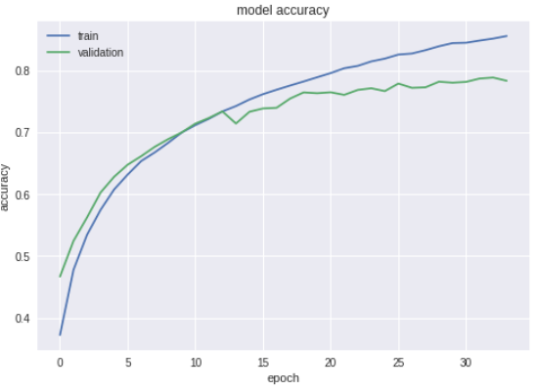

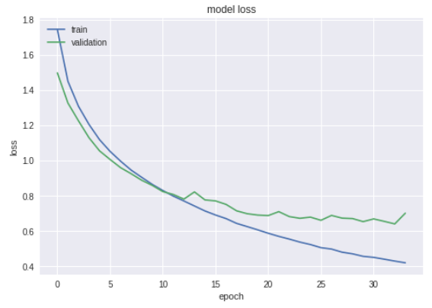

**Experiment 3:**

No of epochs: 34

Batch size: 50

Number of layers: 2

Learning rate:0.0001

Activation functions: relu

Dropout rates: 0.25

Padding: same

Strides: 3

Train on 50000 samples, validate on 10000 samples

Epoch 1/34

50000/50000 [==============================] - 15s 302us/step - loss: 1.8797 - acc: 0.3124 - val_loss: 1.5938 - val_acc: 0.4221

Epoch 2/34

50000/50000 [==============================] - 14s 274us/step - loss: 1.5855 - acc: 0.4220 - val_loss: 1.4963 - val_acc: 0.4612

Epoch 3/34

50000/50000 [==============================] - 14s 275us/step - loss: 1.4728 - acc: 0.4640 - val_loss: 1.3740 - val_acc: 0.5023

Epoch 4/34

50000/50000 [==============================] - 14s 275us/step - loss: 1.4023 - acc: 0.4934 - val_loss: 1.3194 - val_acc: 0.5233

Epoch 5/34

50000/50000 [==============================] - 14s 274us/step - loss: 1.3429 - acc: 0.5168 - val_loss: 1.2556 - val_acc: 0.5526

Epoch 6/34

50000/50000 [==============================] - 14s 278us/step - loss: 1.2949 - acc: 0.5357 - val_loss: 1.1973 - val_acc: 0.5781

Epoch 7/34

50000/50000 [==============================] - 13s 270us/step - loss: 1.2514 - acc: 0.5524 - val_loss: 1.1795 - val_acc: 0.5836

Epoch 8/34

50000/50000 [==============================] - 13s 269us/step - loss: 1.2087 - acc: 0.5688 - val_loss: 1.1270 - val_acc: 0.6001

Epoch 9/34

50000/50000 [==============================] - 13s 268us/step - loss: 1.1692 - acc: 0.5843 - val_loss: 1.0906 - val_acc: 0.6166

Epoch 10/34

50000/50000 [==============================] - 13s 268us/step - loss: 1.1388 - acc: 0.5978 - val_loss: 1.0702 - val_acc: 0.6290

Epoch 11/34

50000/50000 [==============================] - 13s 267us/step - loss: 1.1086 - acc: 0.6064 - val_loss: 1.0462 - val_acc: 0.6352

Epoch 12/34

50000/50000 [==============================] - 13s 269us/step - loss: 1.0780 - acc: 0.6206 - val_loss: 1.0612 - val_acc: 0.6315

Epoch 13/34

50000/50000 [==============================] - 13s 269us/step - loss: 1.0529 - acc: 0.6313 - val_loss: 1.0081 - val_acc: 0.6455

Epoch 14/34

50000/50000 [==============================] - 13s 270us/step - loss: 1.0274 - acc: 0.6361 - val_loss: 0.9675 - val_acc: 0.6615

Epoch 15/34

50000/50000 [==============================] - 13s 269us/step - loss: 1.0034 - acc: 0.6467 - val_loss: 0.9472 - val_acc: 0.6647

Epoch 16/34

50000/50000 [==============================] - 13s 268us/step - loss: 0.9823 - acc: 0.6549 - val_loss: 0.9437 - val_acc: 0.6724

Epoch 17/34

50000/50000 [==============================] - 13s 268us/step - loss: 0.9575 - acc: 0.6637 - val_loss: 0.9095 - val_acc: 0.6787

Epoch 18/34

50000/50000 [==============================] - 14s 272us/step - loss: 0.9375 - acc: 0.6719 - val_loss: 0.8979 - val_acc: 0.6854

Epoch 19/34

50000/50000 [==============================] - 13s 270us/step - loss: 0.9126 - acc: 0.6797 - val_loss: 0.8785 - val_acc: 0.6915

Epoch 20/34

50000/50000 [==============================] - 13s 269us/step - loss: 0.8967 - acc: 0.6863 - val_loss: 0.8614 - val_acc: 0.6999

Epoch 21/34

50000/50000 [==============================] - 13s 268us/step - loss: 0.8850 - acc: 0.6900 - val_loss: 0.8838 - val_acc: 0.6947

Epoch 22/34

50000/50000 [==============================] - 14s 272us/step - loss: 0.8636 - acc: 0.6987 - val_loss: 0.8516 - val_acc: 0.7046

Epoch 23/34

50000/50000 [==============================] - 13s 269us/step - loss: 0.8462 - acc: 0.7046 - val_loss: 0.8287 - val_acc: 0.7131

Epoch 24/34

50000/50000 [==============================] - 13s 267us/step - loss: 0.8338 - acc: 0.7083 - val_loss: 0.8243 - val_acc: 0.7119

Epoch 25/34

50000/50000 [==============================] - 13s 268us/step - loss: 0.8175 - acc: 0.7157 - val_loss: 0.8218 - val_acc: 0.7148

Epoch 26/34

50000/50000 [==============================] - 13s 269us/step - loss: 0.8011 - acc: 0.7203 - val_loss: 0.7926 - val_acc: 0.7251

Epoch 27/34

50000/50000 [==============================] - 13s 268us/step - loss: 0.7897 - acc: 0.7260 - val_loss: 0.8079 - val_acc: 0.7254

Epoch 28/34

50000/50000 [==============================] - 13s 268us/step - loss: 0.7731 - acc: 0.7310 - val_loss: 0.7761 - val_acc: 0.7283

Epoch 29/34

50000/50000 [==============================] - 14s 274us/step - loss: 0.7664 - acc: 0.7322 - val_loss: 0.7844 - val_acc: 0.7295

Epoch 30/34

50000/50000 [==============================] - 13s 270us/step - loss: 0.7508 - acc: 0.7386 - val_loss: 0.7686 - val_acc: 0.7331

Epoch 31/34

50000/50000 [==============================] - 13s 270us/step - loss: 0.7364 - acc: 0.7435 - val_loss: 0.7818 - val_acc: 0.7267

Epoch 32/34

50000/50000 [==============================] - 13s 269us/step - loss: 0.7234 - acc: 0.7471 - val_loss: 0.7559 - val_acc: 0.7385

Epoch 33/34

50000/50000 [==============================] - 13s 264us/step - loss: 0.7135 - acc: 0.7512 - val_loss: 0.7500 - val_acc: 0.7377

Epoch 34/34

50000/50000 [==============================] - 13s 266us/step - loss: 0.6992 - acc: 0.7559 - val_loss: 0.7486 - val_acc: 0.7406

10000/10000 [==============================] - 1s 128us/step

Test loss: 0.7486158525466919

Test accuracy: 0.7406

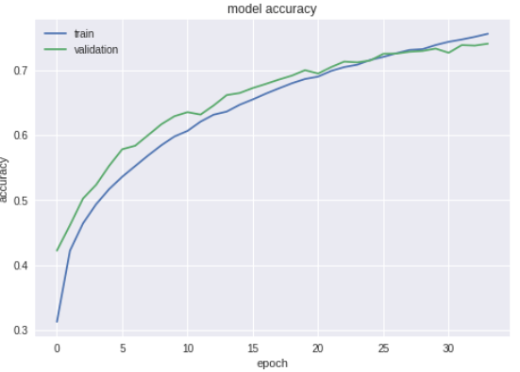

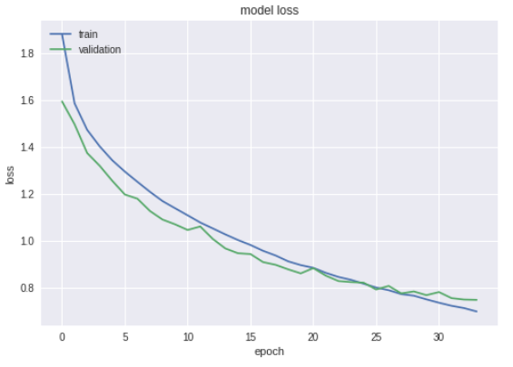

**Experiment 4:**

No of epochs: 34

Batch size: 50

Number of layers: 2

Learning rate:0.0001

Activation functions: relu

Dropout rates: 0.25

Padding: same

Strides: 4

Train on 50000 samples, validate on 10000 samples

Epoch 1/34

50000/50000 [==============================] - 15s 298us/step - loss: 1.9466 - acc: 0.2912 - val_loss: 1.7016 - val_acc: 0.3967

Epoch 2/34

50000/50000 [==============================] - 14s 272us/step - loss: 1.6833 - acc: 0.3909 - val_loss: 1.5735 - val_acc: 0.4325

Epoch 3/34

50000/50000 [==============================] - 14s 272us/step - loss: 1.5677 - acc: 0.4309 - val_loss: 1.4495 - val_acc: 0.4741

Epoch 4/34

50000/50000 [==============================] - 13s 270us/step - loss: 1.4861 - acc: 0.4596 - val_loss: 1.3790 - val_acc: 0.5085

Epoch 5/34

50000/50000 [==============================] - 14s 273us/step - loss: 1.4241 - acc: 0.4844 - val_loss: 1.3213 - val_acc: 0.5294

Epoch 6/34

50000/50000 [==============================] - 14s 272us/step - loss: 1.3752 - acc: 0.5022 - val_loss: 1.2775 - val_acc: 0.5425

Epoch 7/34

50000/50000 [==============================] - 13s 270us/step - loss: 1.3350 - acc: 0.5181 - val_loss: 1.2604 - val_acc: 0.5443

Epoch 8/34

50000/50000 [==============================] - 13s 269us/step - loss: 1.2995 - acc: 0.5321 - val_loss: 1.2042 - val_acc: 0.5694

Epoch 9/34

50000/50000 [==============================] - 13s 269us/step - loss: 1.2666 - acc: 0.5469 - val_loss: 1.2228 - val_acc: 0.5628

Epoch 10/34

50000/50000 [==============================] - 13s 269us/step - loss: 1.2305 - acc: 0.5590 - val_loss: 1.1580 - val_acc: 0.5896

Epoch 11/34

50000/50000 [==============================] - 13s 266us/step - loss: 1.2087 - acc: 0.5706 - val_loss: 1.1383 - val_acc: 0.5952

Epoch 12/34

50000/50000 [==============================] - 13s 266us/step - loss: 1.1834 - acc: 0.5769 - val_loss: 1.1090 - val_acc: 0.6101

Epoch 13/34

50000/50000 [==============================] - 13s 266us/step - loss: 1.1594 - acc: 0.5849 - val_loss: 1.0905 - val_acc: 0.6138

Epoch 14/34

50000/50000 [==============================] - 13s 267us/step - loss: 1.1344 - acc: 0.5971 - val_loss: 1.0670 - val_acc: 0.6261

Epoch 15/34

50000/50000 [==============================] - 13s 265us/step - loss: 1.1153 - acc: 0.6029 - val_loss: 1.0521 - val_acc: 0.6311

Epoch 16/34

50000/50000 [==============================] - 13s 268us/step - loss: 1.0930 - acc: 0.6128 - val_loss: 1.0446 - val_acc: 0.6318

Epoch 17/34

50000/50000 [==============================] - 14s 272us/step - loss: 1.0789 - acc: 0.6179 - val_loss: 1.0553 - val_acc: 0.6288

Epoch 18/34

50000/50000 [==============================] - 13s 266us/step - loss: 1.0607 - acc: 0.6231 - val_loss: 1.0307 - val_acc: 0.6411

Epoch 19/34

50000/50000 [==============================] - 13s 268us/step - loss: 1.0441 - acc: 0.6304 - val_loss: 1.0149 - val_acc: 0.6424

Epoch 20/34

50000/50000 [==============================] - 13s 267us/step - loss: 1.0247 - acc: 0.6362 - val_loss: 0.9985 - val_acc: 0.6485

Epoch 21/34

50000/50000 [==============================] - 13s 265us/step - loss: 1.0139 - acc: 0.6426 - val_loss: 0.9742 - val_acc: 0.6565

Epoch 22/34

50000/50000 [==============================] - 13s 268us/step - loss: 0.9981 - acc: 0.6468 - val_loss: 0.9650 - val_acc: 0.6622

Epoch 23/34

50000/50000 [==============================] - 13s 267us/step - loss: 0.9820 - acc: 0.6498 - val_loss: 0.9641 - val_acc: 0.6621

Epoch 24/34

50000/50000 [==============================] - 13s 269us/step - loss: 0.9704 - acc: 0.6563 - val_loss: 0.9499 - val_acc: 0.6675

Epoch 25/34

50000/50000 [==============================] - 13s 268us/step - loss: 0.9599 - acc: 0.6599 - val_loss: 0.9373 - val_acc: 0.6702

Epoch 26/34

50000/50000 [==============================] - 13s 267us/step - loss: 0.9446 - acc: 0.6644 - val_loss: 0.9392 - val_acc: 0.6703

Epoch 27/34

50000/50000 [==============================] - 13s 266us/step - loss: 0.9317 - acc: 0.6678 - val_loss: 0.9191 - val_acc: 0.6759

Epoch 28/34

50000/50000 [==============================] - 13s 268us/step - loss: 0.9220 - acc: 0.6739 - val_loss: 0.9352 - val_acc: 0.6722

Epoch 29/34

50000/50000 [==============================] - 14s 271us/step - loss: 0.9153 - acc: 0.6764 - val_loss: 0.9077 - val_acc: 0.6810

Epoch 30/34

50000/50000 [==============================] - 13s 265us/step - loss: 0.9004 - acc: 0.6813 - val_loss: 0.9494 - val_acc: 0.6661

Epoch 31/34

50000/50000 [==============================] - 13s 265us/step - loss: 0.8918 - acc: 0.6834 - val_loss: 0.9101 - val_acc: 0.6800

Epoch 32/34

50000/50000 [==============================] - 13s 263us/step - loss: 0.8795 - acc: 0.6904 - val_loss: 0.8946 - val_acc: 0.6849

Epoch 33/34

50000/50000 [==============================] - 13s 262us/step - loss: 0.8700 - acc: 0.6917 - val_loss: 0.8820 - val_acc: 0.6884

Epoch 34/34

50000/50000 [==============================] - 13s 259us/step - loss: 0.8631 - acc: 0.6965 - val_loss: 0.8794 - val_acc: 0.6881

10000/10000 [==============================] - 1s 125us/step

Test loss: 0.8793573153495788

Test accuracy: 0.6881

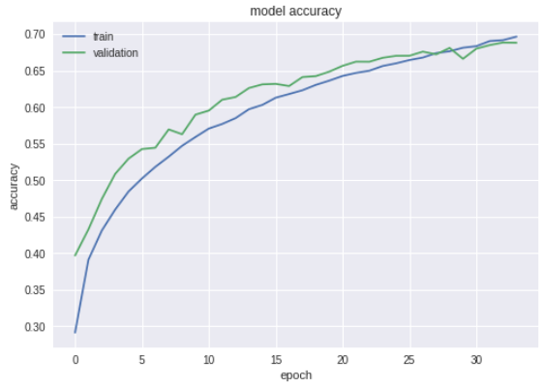

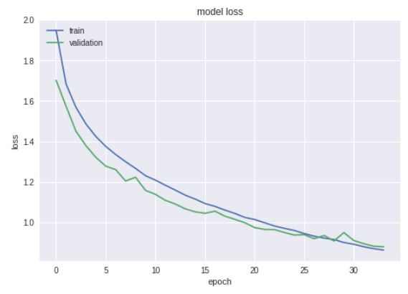

**Experiment 5:**

No of epochs: 34

Batch size: 50

Number of layers: 2

Learning rate:0.0001

Activation functions: relu

Dropout rates: 0.25

Padding: same (In Maxpool function also)

Strides: 3

Train on 50000 samples, validate on 10000 samples

Epoch 1/34

50000/50000 [==============================] - 15s 297us/step - loss: 1.8845 - acc: 0.3120 - val_loss: 1.6733 - val_acc: 0.4042

Epoch 2/34

50000/50000 [==============================] - 14s 286us/step - loss: 1.5974 - acc: 0.4161 - val_loss: 1.4699 - val_acc: 0.4618

Epoch 3/34

50000/50000 [==============================] - 14s 286us/step - loss: 1.4852 - acc: 0.4620 - val_loss: 1.3786 - val_acc: 0.5053

Epoch 4/34

50000/50000 [==============================] - 14s 286us/step - loss: 1.4015 - acc: 0.4932 - val_loss: 1.3558 - val_acc: 0.5177

Epoch 5/34

50000/50000 [==============================] - 14s 289us/step - loss: 1.3380 - acc: 0.5201 - val_loss: 1.2260 - val_acc: 0.5612

Epoch 6/34

50000/50000 [==============================] - 14s 289us/step - loss: 1.2751 - acc: 0.5451 - val_loss: 1.1797 - val_acc: 0.5802

Epoch 7/34

50000/50000 [==============================] - 14s 285us/step - loss: 1.2278 - acc: 0.5611 - val_loss: 1.1557 - val_acc: 0.5924

Epoch 8/34

50000/50000 [==============================] - 14s 285us/step - loss: 1.1873 - acc: 0.5751 - val_loss: 1.1084 - val_acc: 0.6067

Epoch 9/34

50000/50000 [==============================] - 14s 285us/step - loss: 1.1487 - acc: 0.5928 - val_loss: 1.1081 - val_acc: 0.6071

Epoch 10/34

50000/50000 [==============================] - 14s 285us/step - loss: 1.1197 - acc: 0.6057 - val_loss: 1.0818 - val_acc: 0.6199

Epoch 11/34

50000/50000 [==============================] - 14s 287us/step - loss: 1.0842 - acc: 0.6195 - val_loss: 1.0747 - val_acc: 0.6213

Epoch 12/34

50000/50000 [==============================] - 14s 286us/step - loss: 1.0577 - acc: 0.6279 - val_loss: 1.0108 - val_acc: 0.6433

Epoch 13/34

50000/50000 [==============================] - 14s 285us/step - loss: 1.0399 - acc: 0.6353 - val_loss: 0.9670 - val_acc: 0.6631

Epoch 14/34

50000/50000 [==============================] - 14s 285us/step - loss: 1.0113 - acc: 0.6439 - val_loss: 0.9677 - val_acc: 0.6593

Epoch 15/34

50000/50000 [==============================] - 14s 288us/step - loss: 0.9910 - acc: 0.6511 - val_loss: 0.9481 - val_acc: 0.6678

Epoch 16/34

50000/50000 [==============================] - 14s 287us/step - loss: 0.9703 - acc: 0.6581 - val_loss: 0.9345 - val_acc: 0.6778

Epoch 17/34

50000/50000 [==============================] - 14s 286us/step - loss: 0.9492 - acc: 0.6678 - val_loss: 0.9589 - val_acc: 0.6688

Epoch 18/34

50000/50000 [==============================] - 14s 286us/step - loss: 0.9333 - acc: 0.6741 - val_loss: 0.9055 - val_acc: 0.6849

Epoch 19/34

50000/50000 [==============================] - 14s 285us/step - loss: 0.9133 - acc: 0.6803 - val_loss: 0.9032 - val_acc: 0.6879

Epoch 20/34

50000/50000 [==============================] - 14s 287us/step - loss: 0.8996 - acc: 0.6848 - val_loss: 0.8663 - val_acc: 0.7038

Epoch 21/34

50000/50000 [==============================] - 14s 286us/step - loss: 0.8805 - acc: 0.6915 - val_loss: 0.8807 - val_acc: 0.6937

Epoch 22/34

50000/50000 [==============================] - 14s 286us/step - loss: 0.8653 - acc: 0.6962 - val_loss: 0.8511 - val_acc: 0.7048

Epoch 23/34

50000/50000 [==============================] - 14s 285us/step - loss: 0.8505 - acc: 0.7026 - val_loss: 0.8401 - val_acc: 0.7063

Epoch 24/34

50000/50000 [==============================] - 14s 285us/step - loss: 0.8379 - acc: 0.7062 - val_loss: 0.8243 - val_acc: 0.7139

Epoch 25/34

50000/50000 [==============================] - 14s 286us/step - loss: 0.8193 - acc: 0.7121 - val_loss: 0.8111 - val_acc: 0.7189

Epoch 26/34

50000/50000 [==============================] - 14s 287us/step - loss: 0.8095 - acc: 0.7147 - val_loss: 0.8286 - val_acc: 0.7129

Epoch 27/34

50000/50000 [==============================] - 14s 290us/step - loss: 0.7965 - acc: 0.7209 - val_loss: 0.8119 - val_acc: 0.7176

Epoch 28/34

50000/50000 [==============================] - 14s 287us/step - loss: 0.7892 - acc: 0.7237 - val_loss: 0.7952 - val_acc: 0.7245

Epoch 29/34

50000/50000 [==============================] - 14s 288us/step - loss: 0.7713 - acc: 0.7288 - val_loss: 0.8148 - val_acc: 0.7173

Epoch 30/34

50000/50000 [==============================] - 14s 286us/step - loss: 0.7622 - acc: 0.7336 - val_loss: 0.7698 - val_acc: 0.7347

Epoch 31/34

50000/50000 [==============================] - 14s 287us/step - loss: 0.7503 - acc: 0.7385 - val_loss: 0.7732 - val_acc: 0.7360

Epoch 32/34

50000/50000 [==============================] - 14s 287us/step - loss: 0.7395 - acc: 0.7423 - val_loss: 0.7787 - val_acc: 0.7342

Epoch 33/34

50000/50000 [==============================] - 14s 286us/step - loss: 0.7315 - acc: 0.7454 - val_loss: 0.7844 - val_acc: 0.7322

Epoch 34/34

50000/50000 [==============================] - 14s 286us/step - loss: 0.7197 - acc: 0.7473 - val_loss: 0.7537 - val_acc: 0.7433

10000/10000 [==============================] - 1s 130us/step

Test loss: 0.7536503143310547

Test accuracy: 0.7433

